Management Control System

Software Training Materials

**Table of Contents**

1. INTRODUCTION OF MANAGEMENT CONTROL SYSTEM 5

How to Log in the MCS 6

2. FINANCE & ACCOUNTS WING 6

3.MIS PAYROLL MANAGEMENT (SUB MODULE) 8

4.MIS PAYROLL MANAGEMENT MENU OVERVIEW 9

4.1: HR Menu Overview 10

4.1.1.1: Employees (HR) View of all Employees data 10

4.1.1.2: Employees (HR) View of Employee (Personal) Data 11

Employee (Personal) Data Print: Click on the print button after that looks like printing functionality will display. 12

4.1.1.3: Employees (HR) View of Employee (Others) Data 13

Employee (Others) Data Print: Click on the print button after that looks like below printing functionality will appear. 14

4.1.1.4: Employees (HR) View of Employee (Increment) Data 14

Employee (Increment) Data Print: Click on the print button after that looks like below printing functionality will appear. 15

4.1.1.5: Employees (HR) View of Employee (Training) Data 16

Employee (Training) Data Print: Click on the print button after that looks like below printing functionality will appear. 16

4.1.1.6: Employees (HR) Search 17

4.1.2.1: Others (HR) Add Others Info input field 17

4.1.2.2: Others (HR) View of Details Others Infromation 18

4.1.2.3: Others (HR) View of Single Details 19

4.1.2.3.1: Others (HR) View of Single Details Print 20

4.1.2.4: Others (HR) Edit 21

4.1.2.5: Others (HR) Delete 21

4.1.2.6: Others (HR) Search 22

4.1.2.7: Others (HR) View Reports 23

4.1.3.1: Increments (HR) Add New Increment input field 24

4.1.3.2: Increments (HR) View details of increment information 25

4.1.3.3: Increments (HR) Increment Information Edit 25

4.1.3.4: Increments (HR) Delete increment data 26

4.1.3.5: Increments (HR) Search increment information 26

4.2: Allowance Menu Overview 27

4.2.1.1: (Allowance) Entering allowance page input field 27

Adding & updating allowance input field: After clicking on the next button then looks like below adding & updating input form will display. 28

4.3: Deduction Menu Overview 29

4.3.1.1: (Deduction) Entering the Deduction page input field 29

Adding & updating the deduction input field: After clicking on the next button then looks like below adding & updating input form will display. 30

4.4: Loan Menu Overview 30

4.4.1.1: (Loan) Add Loan input form 30

4.4.1.2: (Loan) View of all loan information 31

4.4.1.3: (Loan) View of single employee details info 31

4.4.1.4: (Loan) Add Loan types input field 32

4.4.1.5: (Loan)View list of loan types 33

List of Loan types edit: Click on the edit button after that looks like below scenario will appear. User can update the value as user required. 33

4.4.1.7: (Loan) Search loan information 34

4.5: Salary Menu Overview 34

4.5.1.1: Salary Process (Salary) Month wise salary process input field 35

4.5.2.1: Salary Statement (Salary) Month and Grade wise salary input field 35

Month wise all employee salary report: Fill in the month wise salary input field with appropriate value and clicks the search button ,it will redirect to month wise salary report page 36

Month wise single employee salary Details : Click on the view button, it will redirect to month wise single employee salary details page. 36

Month wise all employee salary report generate: Clicks the view all pdf button ,it will redirect to month wise all employees salary details page. 37

Month wise all employee salary report Print: Click on the print button after that looks like printing functionality will appear. 38

5.CPF MANAGEMENT (SUB MODULE) 38

6. CPF MANAGEMENT MENUS OVERVIEW 39

6.1: Opening Balance Menu Overview 41

6.1.1.1: Create (Opening Balance) Accounts Opening Balance Entry Form 41

6.1.2.1: Manage (Opening Balance) View of Details accounts opening balance 42

6.1.2.2: Manage (Opening Balance) Opening balance data edit form 43

6.1.2.3: Manage (Opening Balance) Delete opening balance data 43

6.1.2.4: Manage (Opening Balance) Search opening balance data 44

6.1.3.1: Report (Opening Balance) incomplete(under processing…..) 45

6.2: Sub Opening Balance Menu Overview 45

6.2.1.1: Create (Sub Opening Balance) Accounts Sub Opening Balance Entry Form 45

6.2.2.1: Manage (Sub Opening Balance) View of details sub opening balance 46

6.2.2.2: Manage (Sub Opening Balance) View of details sub opening balance 47

6.2.2.3: Manage (Sub Opening Balance) Delete 47

6.2.2.4: Manage (Sub Opening Balance) Search 48

6.2.3.1: Report (Sub Opening Balance) incomplete(under processing…..) 49

7.FDR MANAGEMENT (SUB MODULE) 49

8.FDR MANAGEMENT MENU OVERVIEW 50

8.1: Settings Menu Overview 51

8.1.1.1: Bank (Settings) Add Bank Entry Form 51

8.1.1.2: Bank (Settings) View details of bank 52

8.1.1.3: Bank (Settings) Update bank type info 52

8.1.1.4: Bank (Settings) Update branch type info 53

8.1.1.5: Bank (Settings) Search 54

8.2: FDR Create Menu Overview 54

8.2.1.1: (FDR Create) input field 55

8.3: BBA FDR Menu Overview 55

8.3.1.1: (BBA FDR) View of BBA FDR Information 55

8.3.1.2: (BBA FDR) View of Single Details 56

8.3.1.3: (BBA FDR) Update input form 57

8.3.1.4: (BBA FDR) Search 58

8.4: Depreciation FDR Menu Overview 58

8.4.1.1: (Depreciation FDR) View of Depreciation FDR Information 58

8.4.1.2: (Depreciation FDR) View of Single Details 59

8.4.1.3: (Depreciation FDR) Update input form 60

8.4.1.4: (Depreciation FDR) Search 61

8.5: Kallyan Trust Menu Overview (Not working ,under processing……) 61

8.6: Pension Fund Menu Overview (Not working ,under processing……) 61

8.7: Report Menu Overview 61

8.7.1.1: (Report) FDR Report generator input field 62

# 1. INTRODUCTION OF MANAGEMENT CONTROL SYSTEM

……….

….

…….

…….

…….

Link for MCS is <http://192.168.3.7:3000/> which is accessible within BBA’s local network . After search will open a login page. Which is like –

### How to Log in the MCS

Figure 1: Log in Page

**Steps to Log in MCS**

1. User will input his Username
2. User will input his Password
3. Click Log In Button

If the username & password are correct, users will get access to the system.

# 2. FINANCE & ACCOUNTS WING

For Finance & Accounts module –

**Steps to Enter in Finance & Accounts**

1. After login will show this dashboard of MCS.

2. Click on the Finance & Accounts.

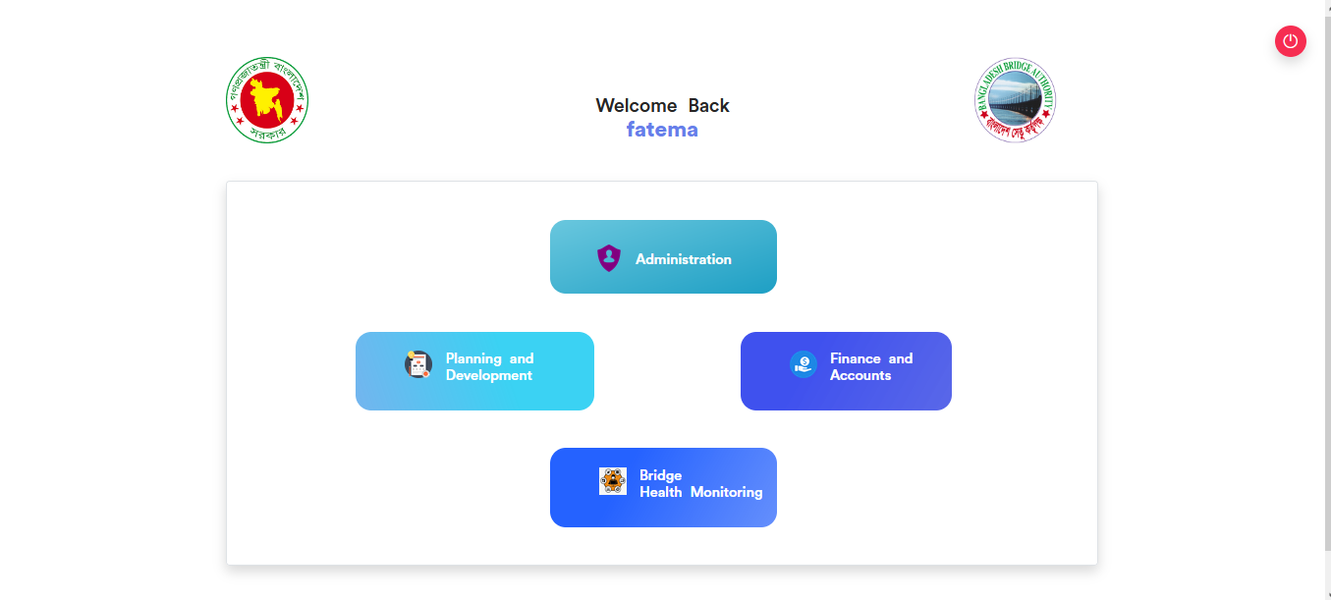

Figure 2.1: Dashboard of MCS

After entering into Finance & Accounts then there will show another dashboard with another four (4) Submodules. Such as-

1.Accounts & Budget Management

2.MIS Payroll Management

3.FDR Management

4.CPF Management

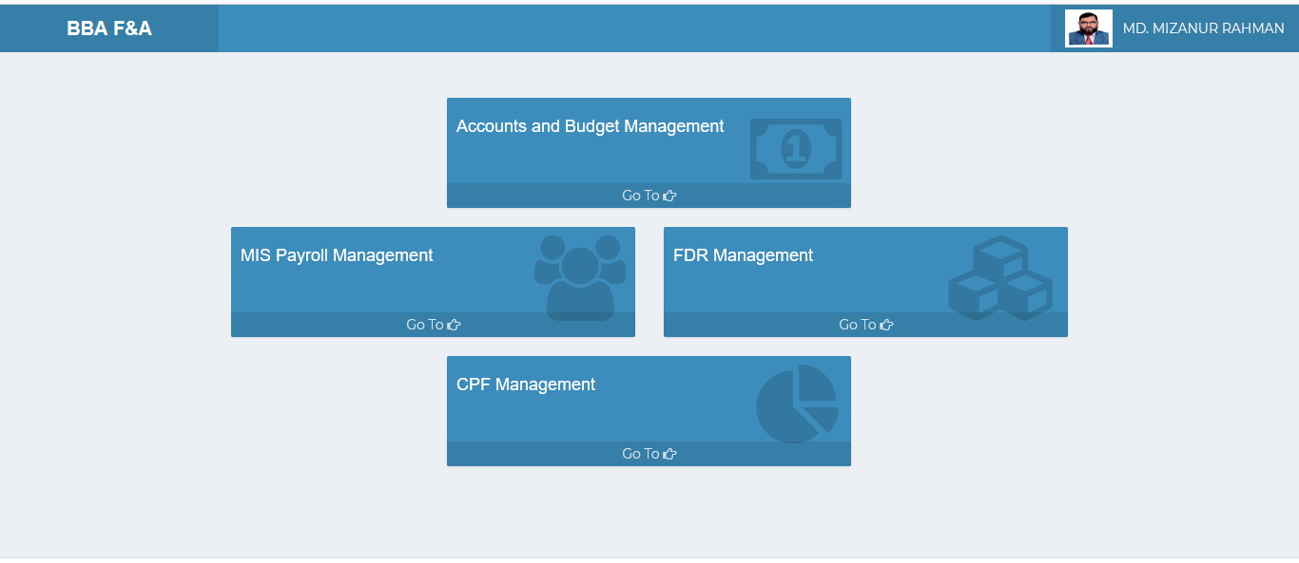

Figure 2.2: Dashboard of Finance & accounts Module.

**Overview of Finance & Accounts Sub Modules**

# 3.MIS PAYROLL MANAGEMENT (SUB MODULE)

After clicking into MIS Payroll Management, it will redirect to the (MIS Payroll Sub Module) dashboard with some menus.

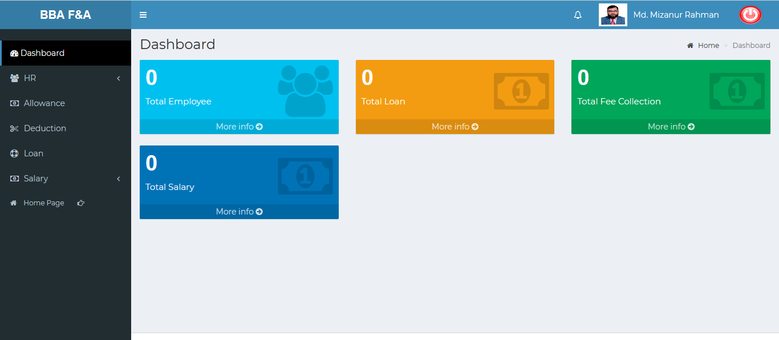

Figure 3: Dashboard of MIS payroll (sub module).

There are four segments on the right side of the MIS Payroll Management Dashboard Such as **Total Employee, Total Loan ,Total Fee Collection** And **Total Salary.**

To get the details info about (**Total Employee, Total Loan ,Total Fee Collection, Total Salary**) just click on the More info link after that it will redirect to the relevant details info page.

# 4.MIS PAYROLL MANAGEMENT MENU OVERVIEW

**MIS Payroll Management Menu Overview**

## 4.1: HR Menu Overview

**Overview of Settings**

Click on the HR menu after that there will appear three (03) sub-menu & they are **Employees , Others** and **Increments.**

### 4.1.1.1: Employees (HR) View of all Employees data

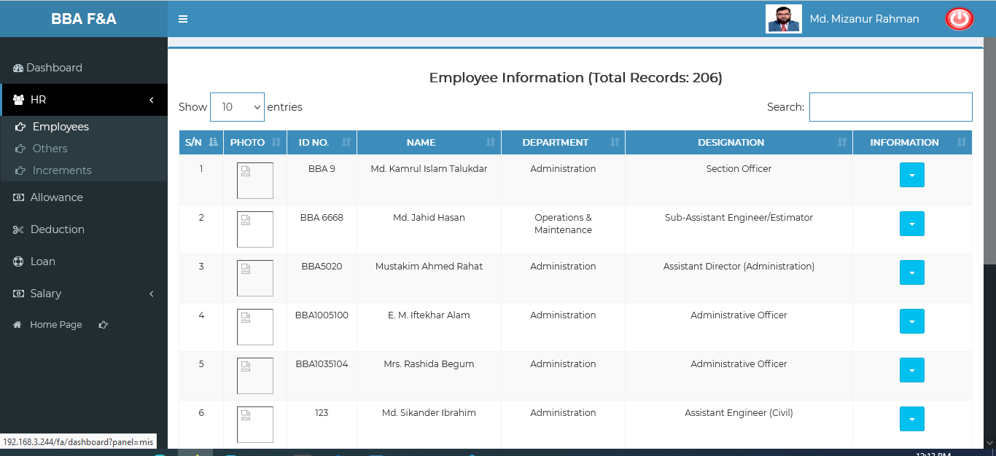

Figure 4.1.1.1: view of all employees details

### 4.1.1.2: Employees (HR) View of Employee (Personal) Data

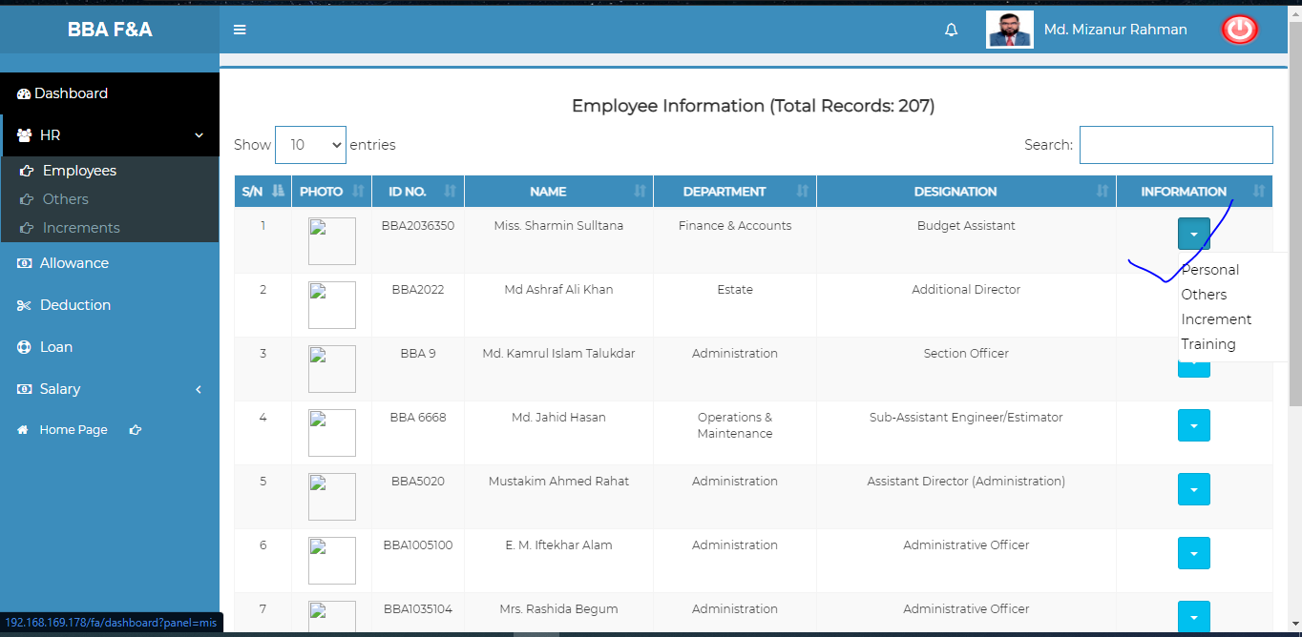

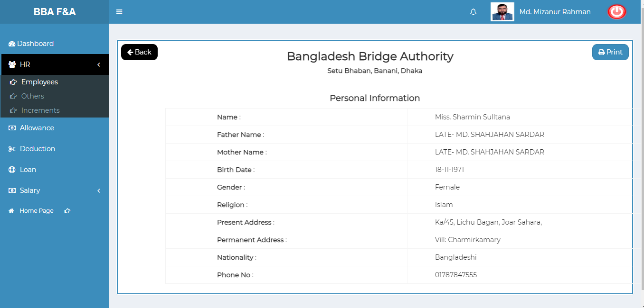

Figure 4.1.1.2: employees (HR)View of employee (personal) data

### Employee (Personal) Data Print: Click on the print button after that looks like printing functionality will display.

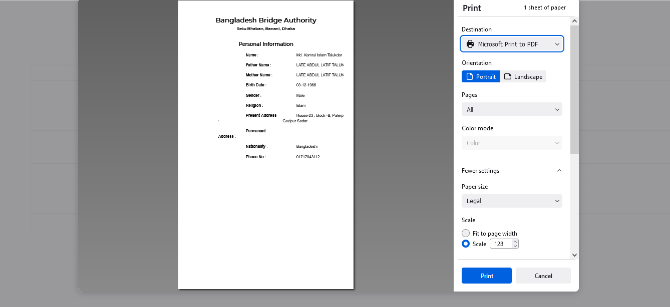

Figure 4.1.1.2.1: employee (personal) data Print

### 4.1.1.3: Employees (HR) View of Employee (Others) Data

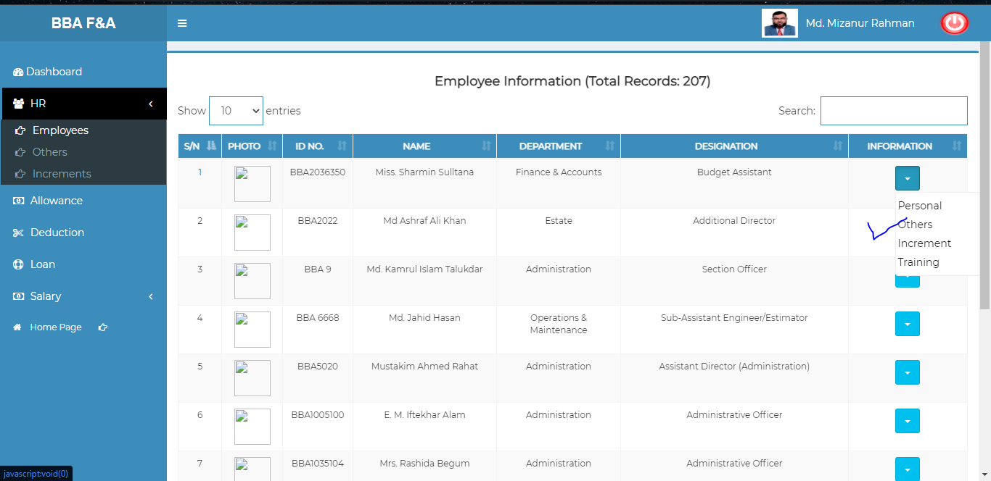

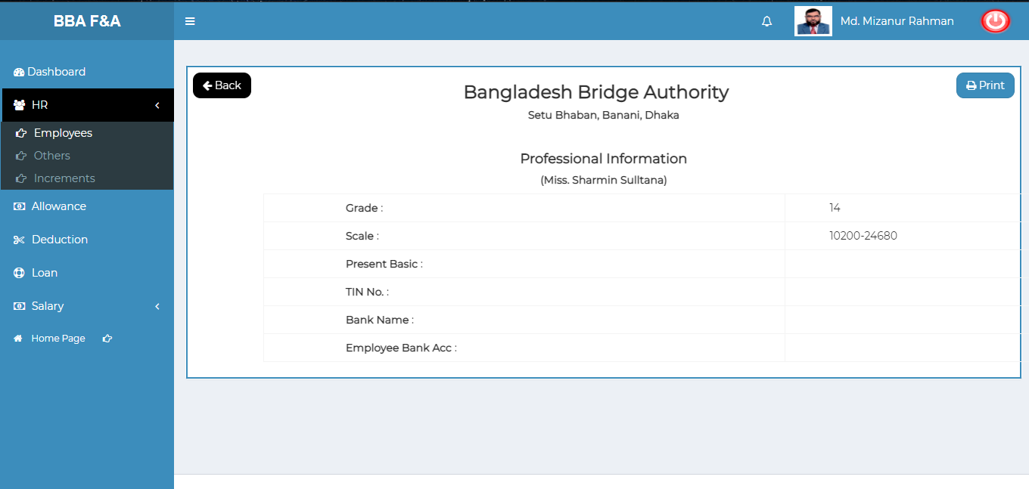

Figure 4.1.1.3: employees (HR)View of employee (others) data

### Employee (Others) Data Print: Click on the print button after that looks like below printing functionality will appear.

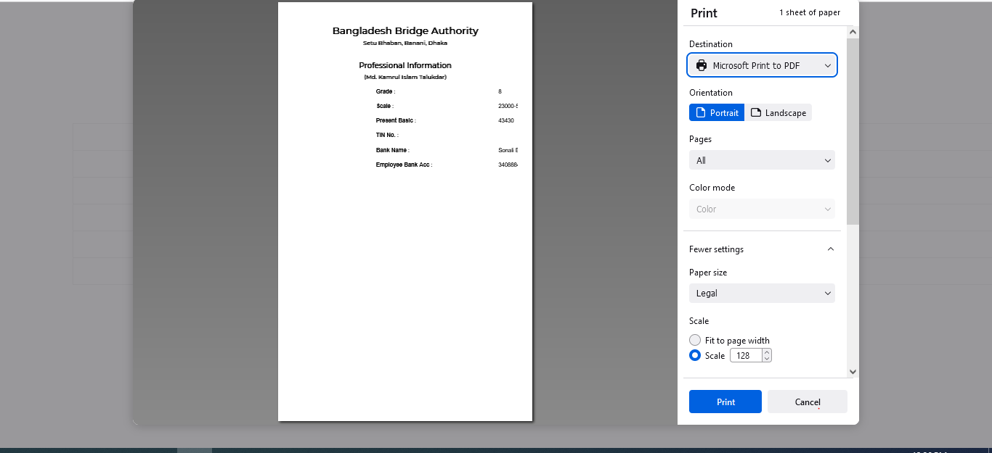

Figure 4.1.1.3.1: employee (others) data Print

### 4.1.1.4: Employees (HR) View of Employee (Increment) Data

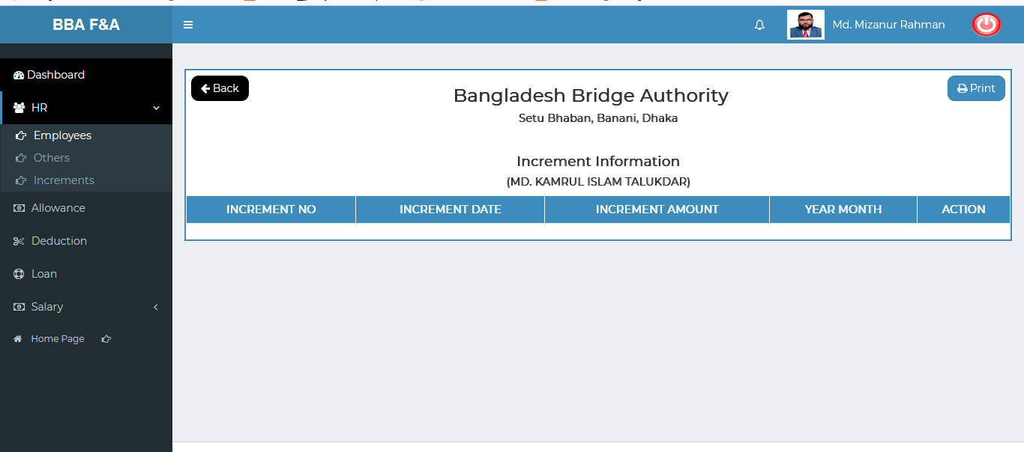

Figure 4.1.1.4: employees (HR)View of employee (Increment) data

### Employee (Increment) Data Print: Click on the print button after that looks like below printing functionality will appear.

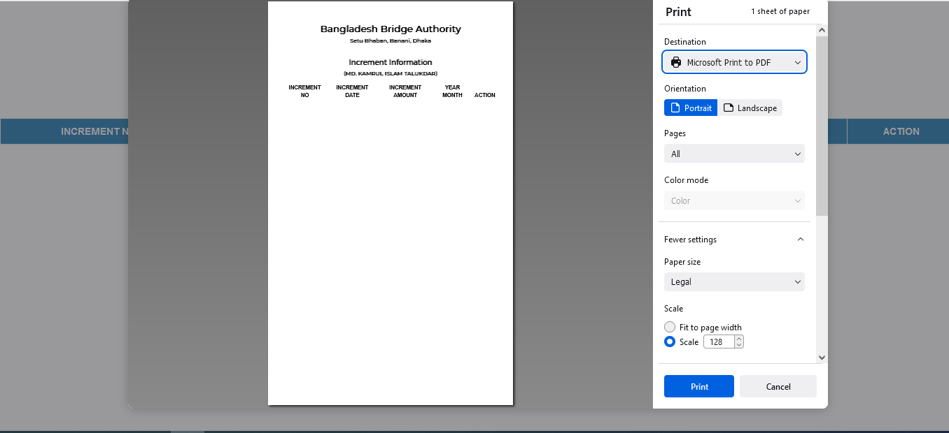

Figure 4.1.1.4.1: employee (increment) data Print

### 4.1.1.5: Employees (HR) View of Employee (Training) Data

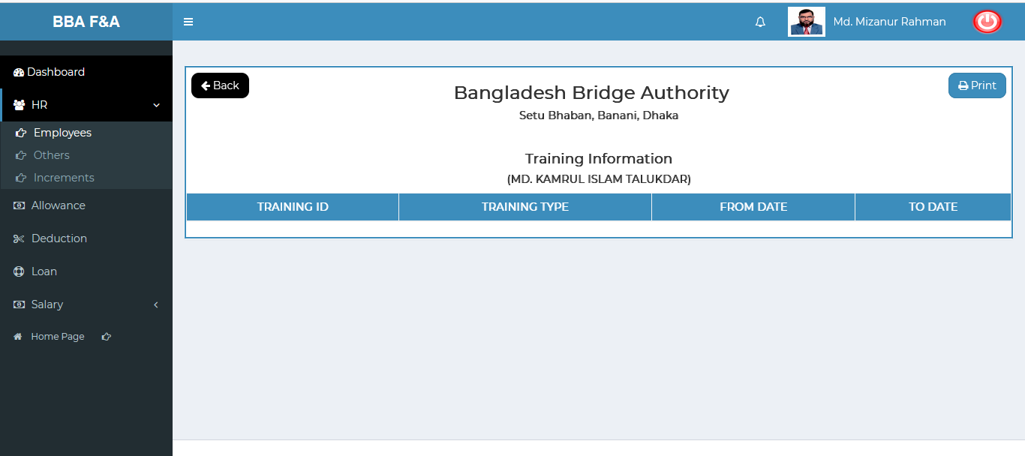

Figure 4.1.1.5: employees (HR)View of employee (Training) data

### Employee (Training) Data Print: Click on the print button after that looks like below printing functionality will appear.

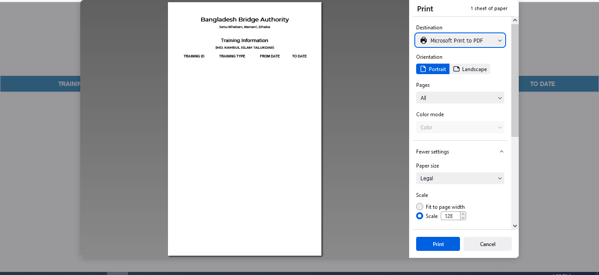

Figure 4.1.1.5.1: employee (training) data Print

### 4.1.1.6: Employees (HR) Search

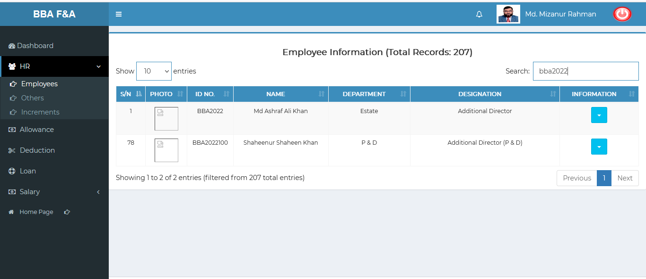

Figure 4.1.1.6: employees (HR) search

### 4.1.2.1: Others (HR) Add Others Info input field

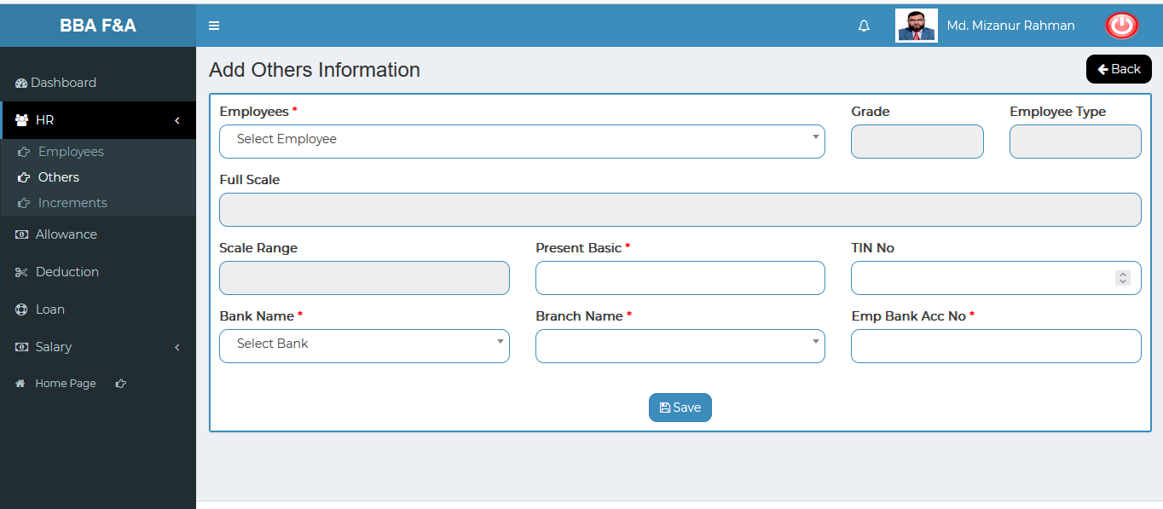

Figure 4.1.2.1: add others input field

### 4.1.2.2: Others (HR) View of Details Others Infromation

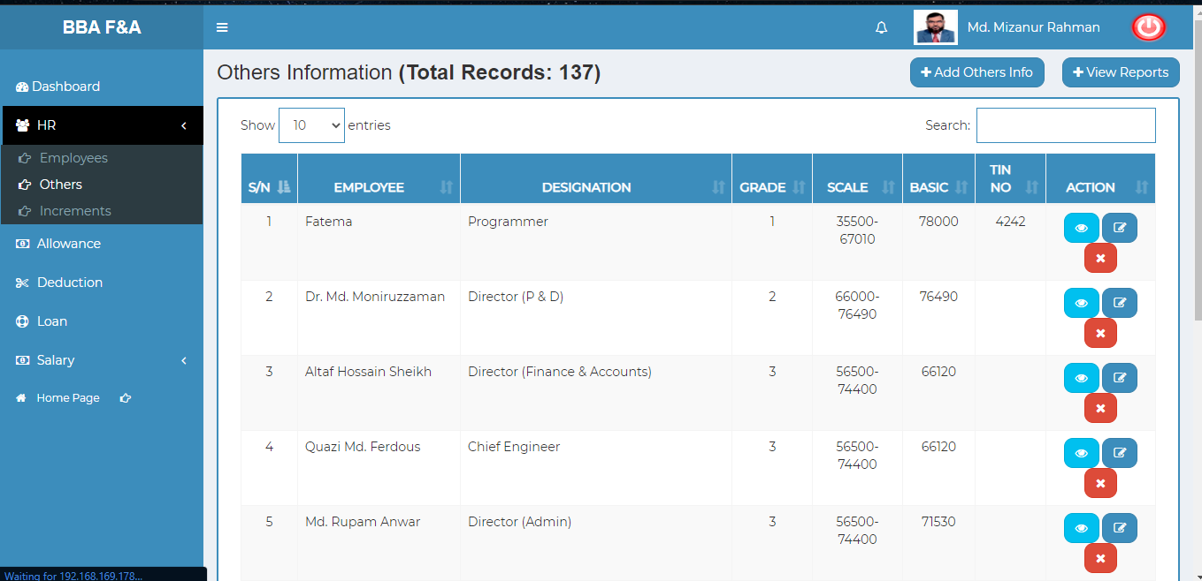

Figure 4.1.2.2: View of details others information

### 4.1.2.3: Others (HR) View of Single Details

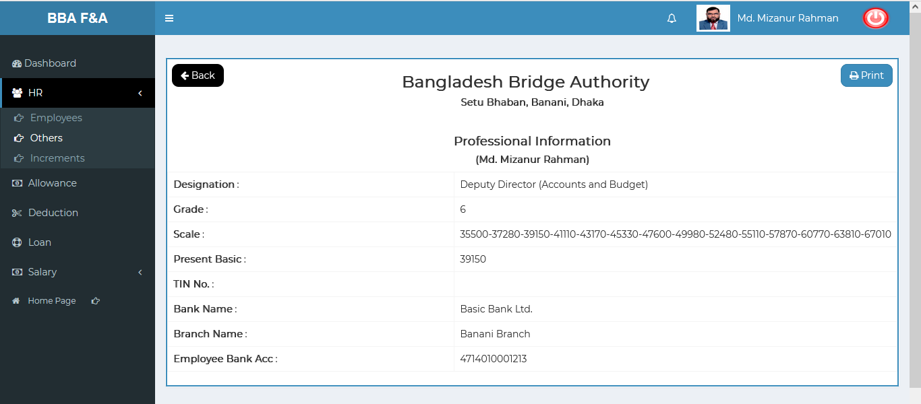

Figure 4.1.2.3: others (HR) View of single details others information

### 4.1.2.3.1: Others (HR) View of Single Details Print

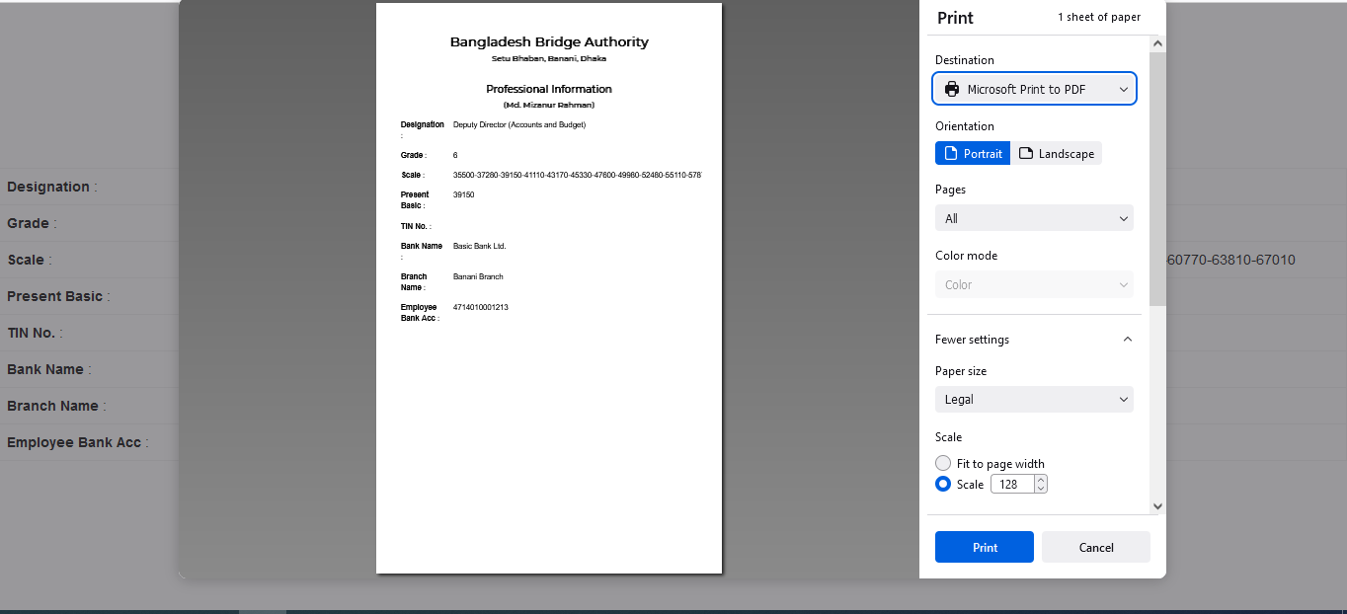

Figure 4.1.2.3.1: others (HR) View of single details print

### 4.1.2.4: Others (HR) Edit

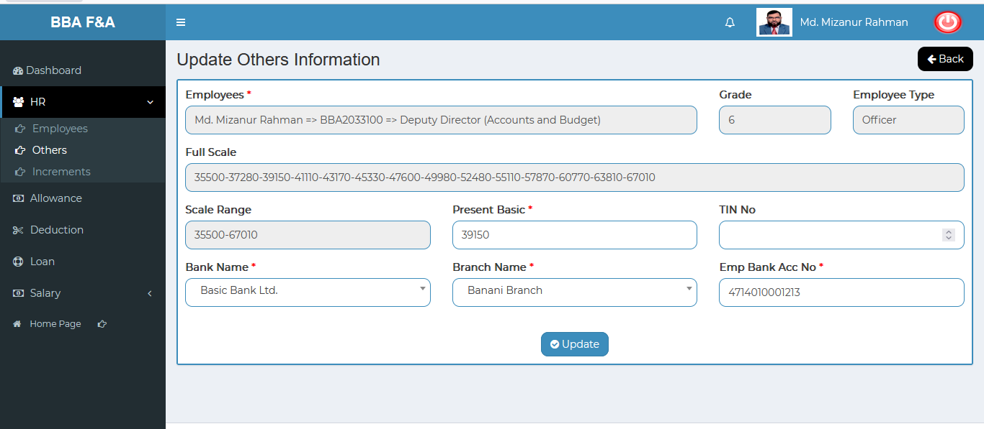

Figure 4.1.2.4: others (HR) edit

### 4.1.2.5: Others (HR) Delete

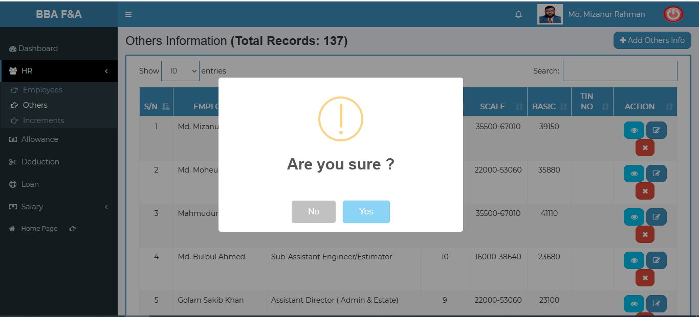

Figure 4.1.2.5: others (HR) Delete

### 4.1.2.6: Others (HR) Search

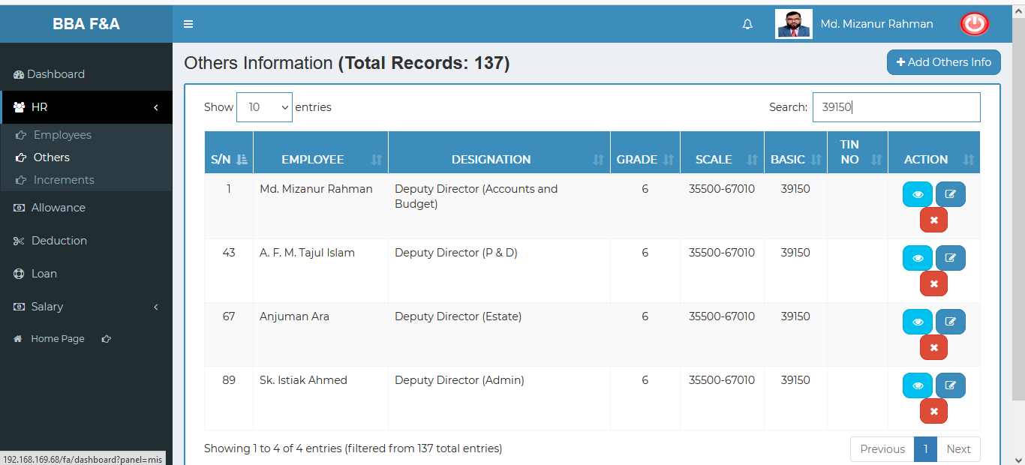

Figure 4.1.2.6: search Others information

### 4.1.2.7: Others (HR) View Reports

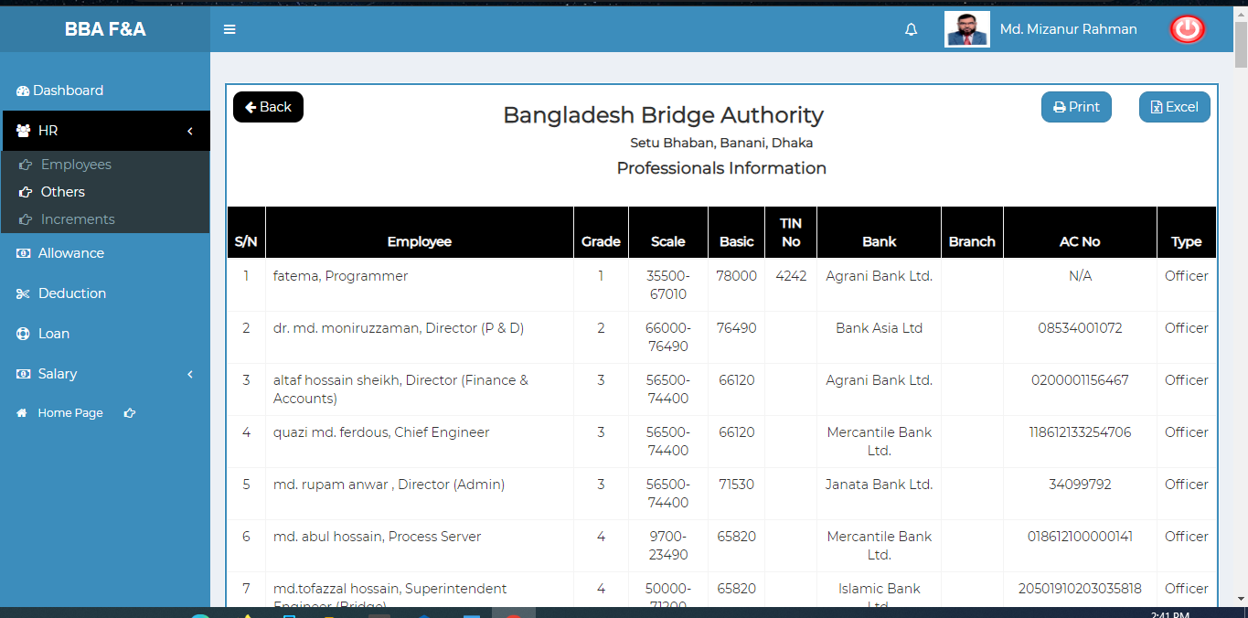

Figure 4.1.2.7: View report

**Download Excel File**:To download the excel file click on the print button

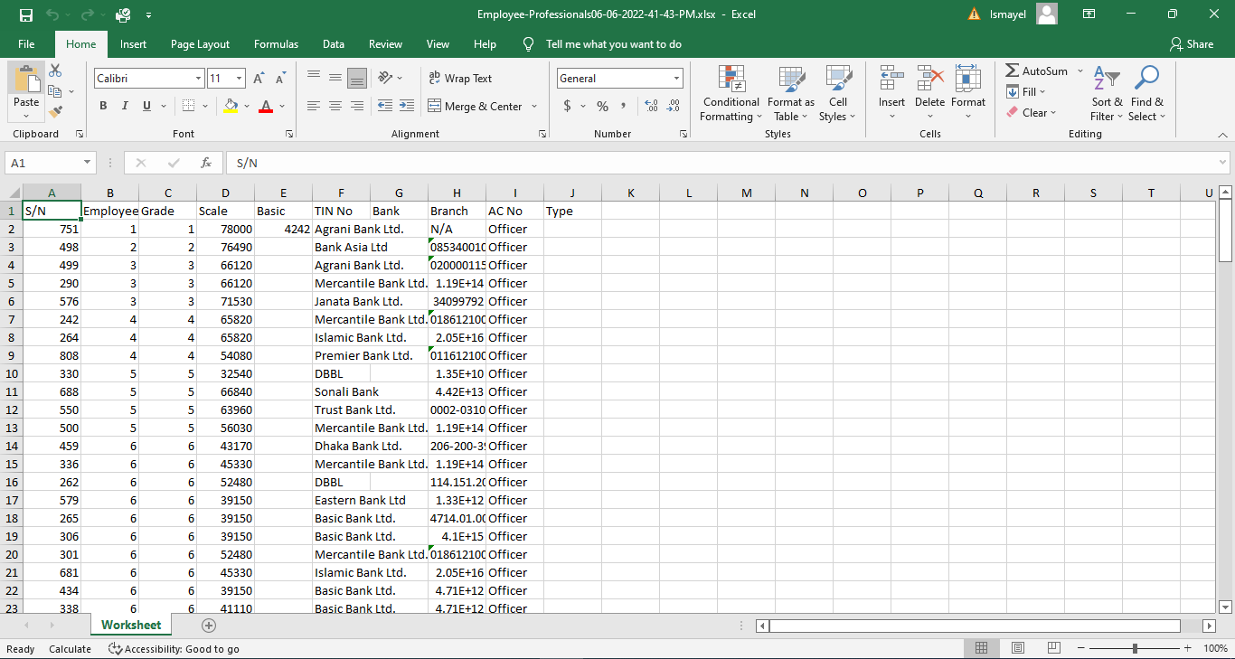

Figure 4.1.2.7: downloaded excel file

### 4.1.3.1: Increments (HR) Add New Increment input field

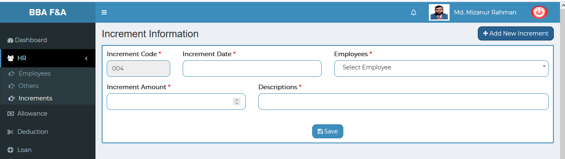

Figure 4.1.3.1: add new increment input field

### 4.1.3.2: Increments (HR) View details of increment information

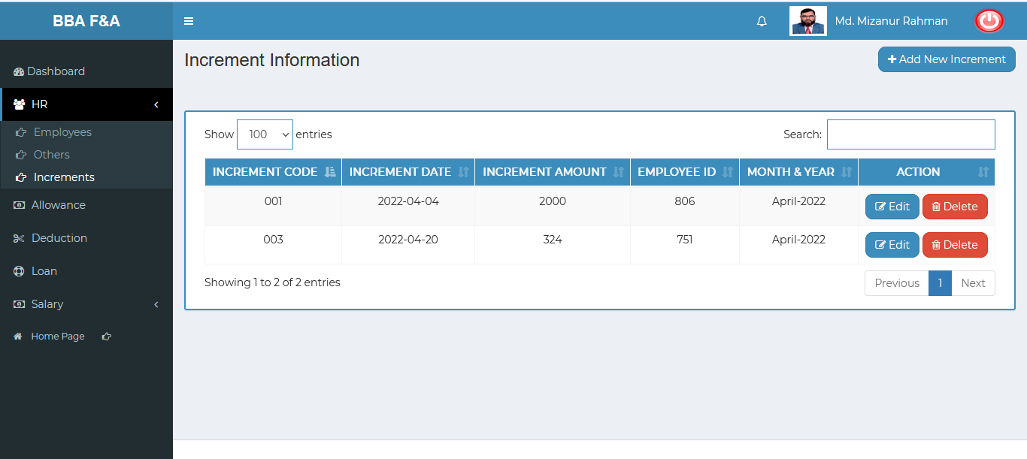 Figure 4.1.3.2: view details of increment information

### 4.1.3.3: Increments (HR) Increment Information Edit

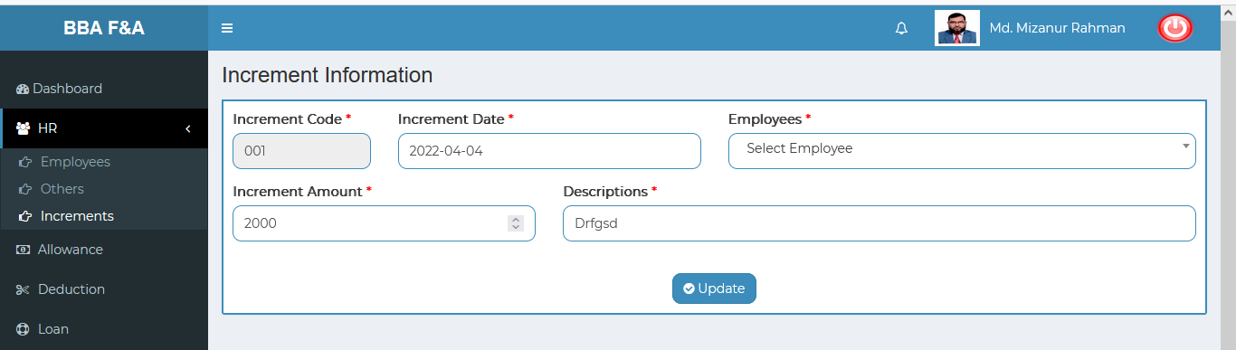

Figure 4.1.3.3: Increments information editform

### 4.1.3.4: Increments (HR) Delete increment data

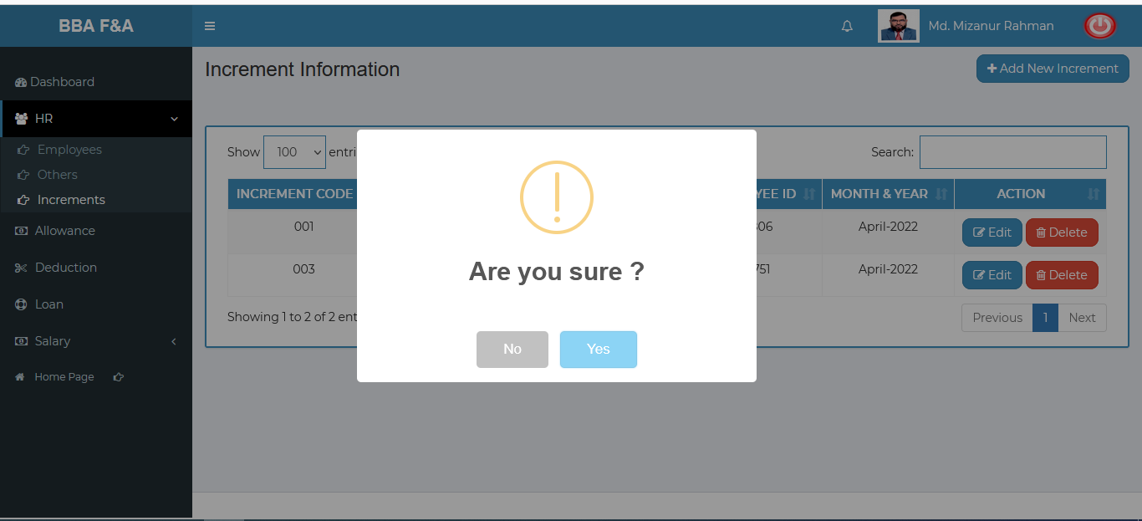 Figure 4.1.3.4: delete increment data

### 4.1.3.5: Increments (HR) Search increment information

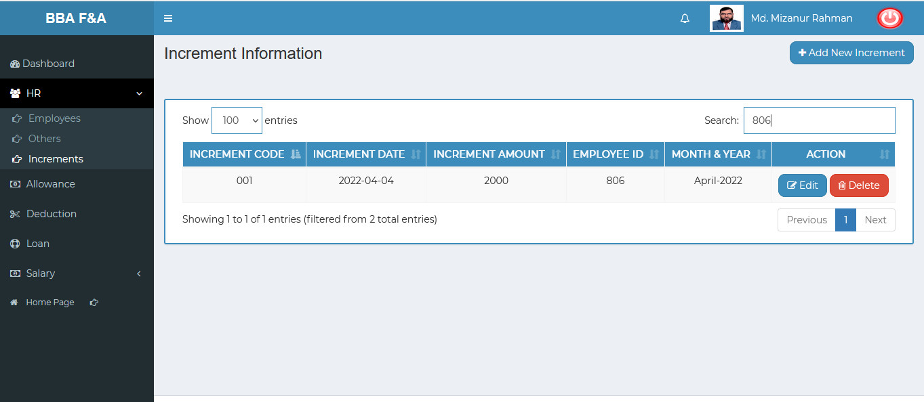

Figure 4.1.3.5: Search increment information

## 4.2: Allowance Menu Overview

**Overview of Allowance**

### 4.2.1.1: (Allowance) Entering allowance page input field

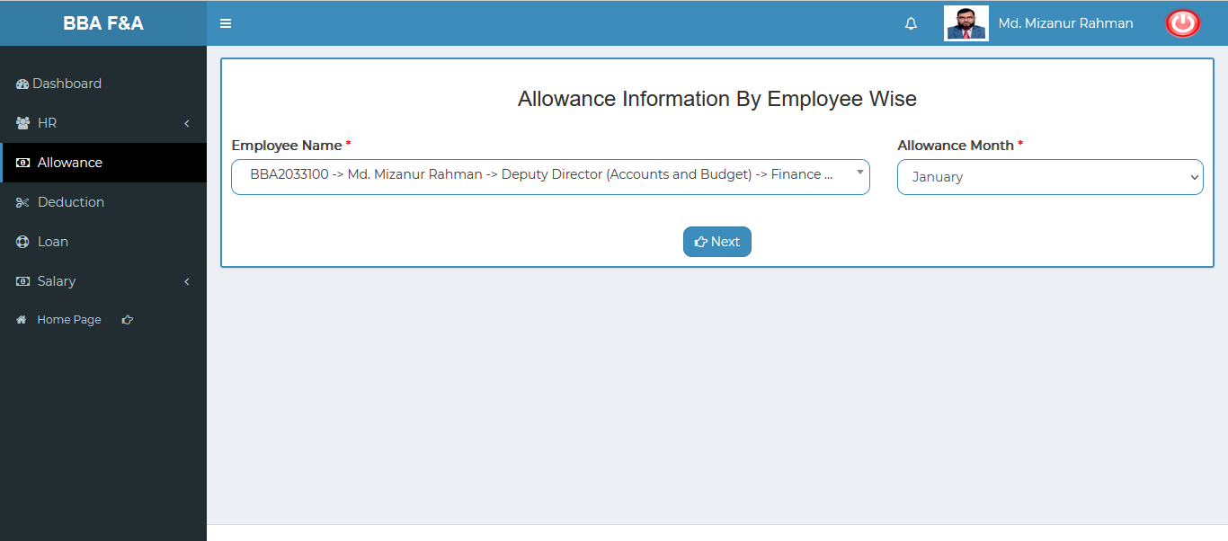

Figure 4.2.1.1: entering allowance page input field

### Adding & updating allowance input field: After clicking on the next button then looks like below adding & updating input form will display.

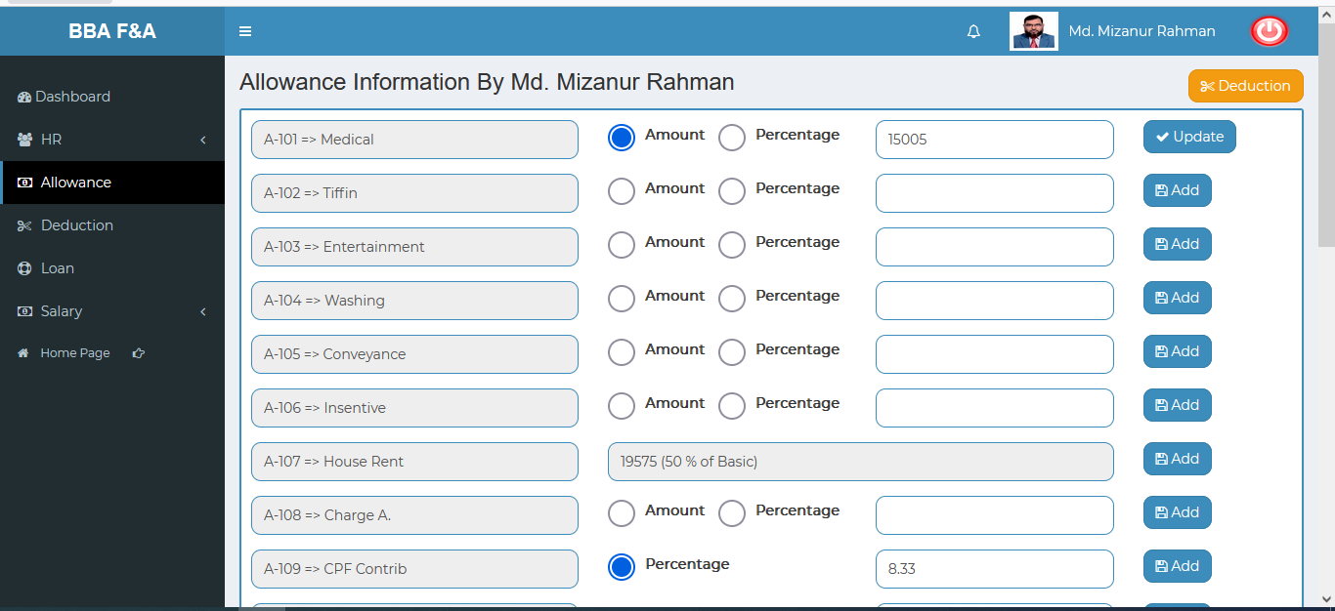

Figure 4.2.1.2: adding & updating allowance input field

## 4.3: Deduction Menu Overview

**Overview of Deduction**

### 4.3.1.1: (Deduction) Entering the Deduction page input field

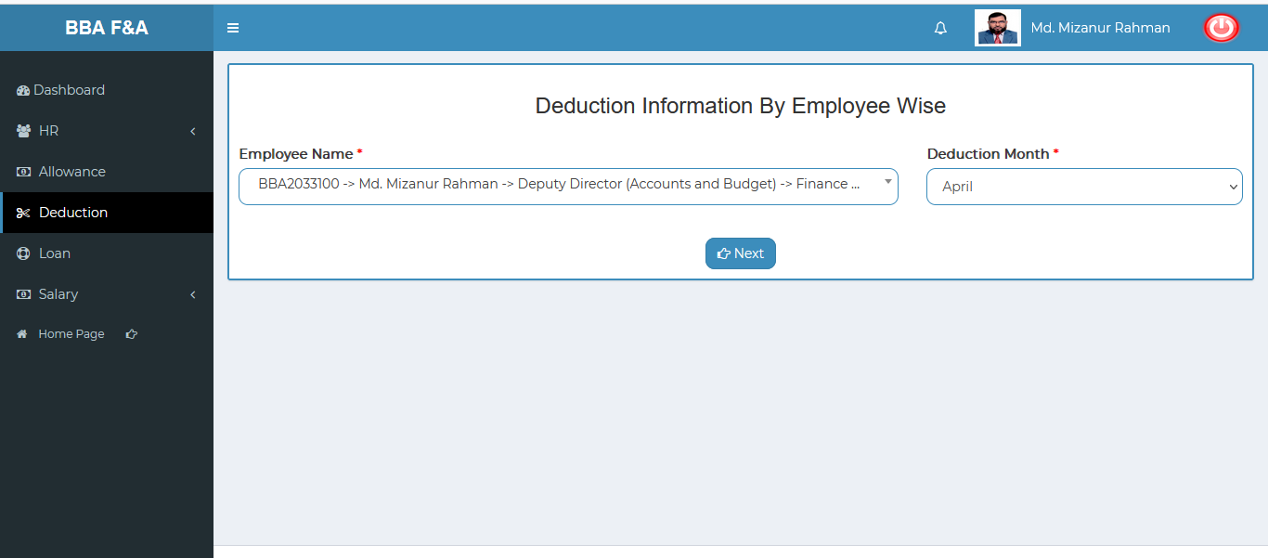

Figure 4.3.1.1: entering deduction page input field

### Adding & updating the deduction input field: After clicking on the next button then looks like below adding & updating input form will display.

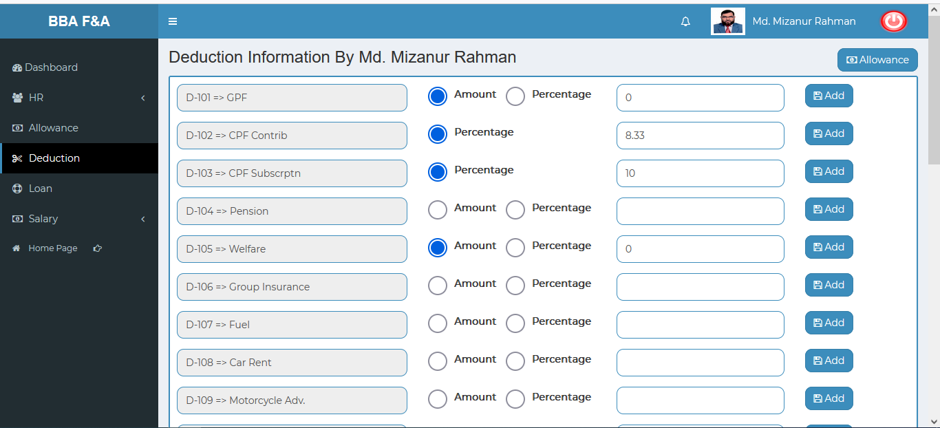

Figure 4.3.1.2: adding & updating deduction input field

## 4.4: Loan Menu Overview

**Overview of Loan**

### 4.4.1.1: (Loan) Add Loan input form

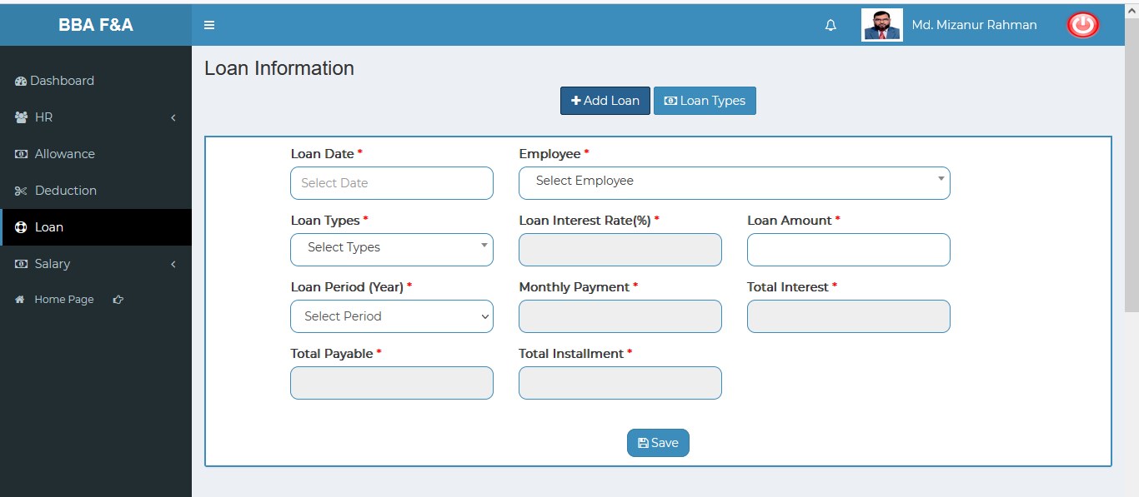

Figure 4.4.1.1: add loan input form

### 4.4.1.2: (Loan) View of all loan information

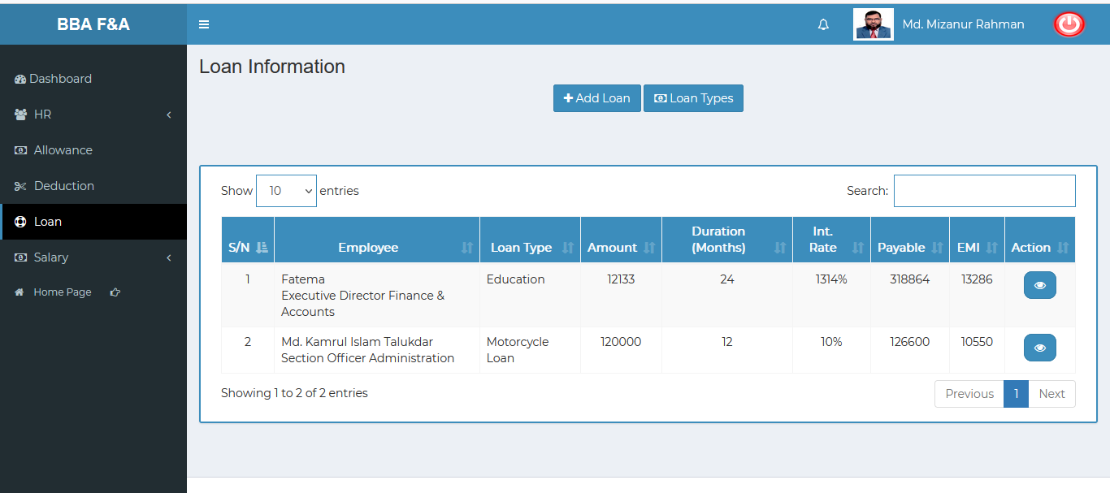

Figure 4.4.1.2: view of all loan information

### 4.4.1.3: (Loan) View of single employee details info

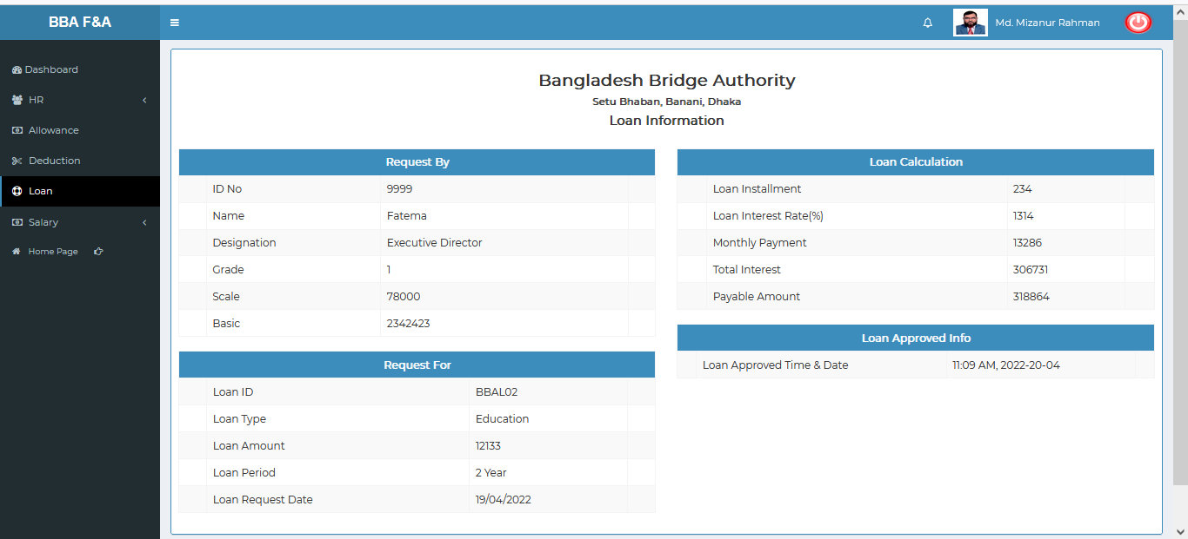

Figure 4.4.1.3: view of single employee details info

### 4.4.1.4: (Loan) Add Loan types input field

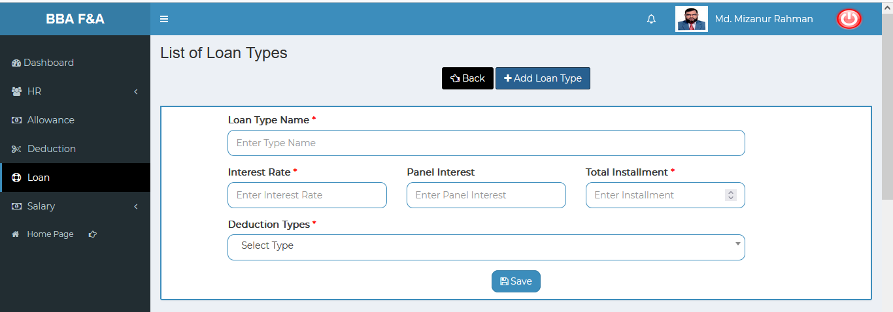

Figure 4.4.1.4: add loan types input field

### 4.4.1.5: (Loan)View list of loan types

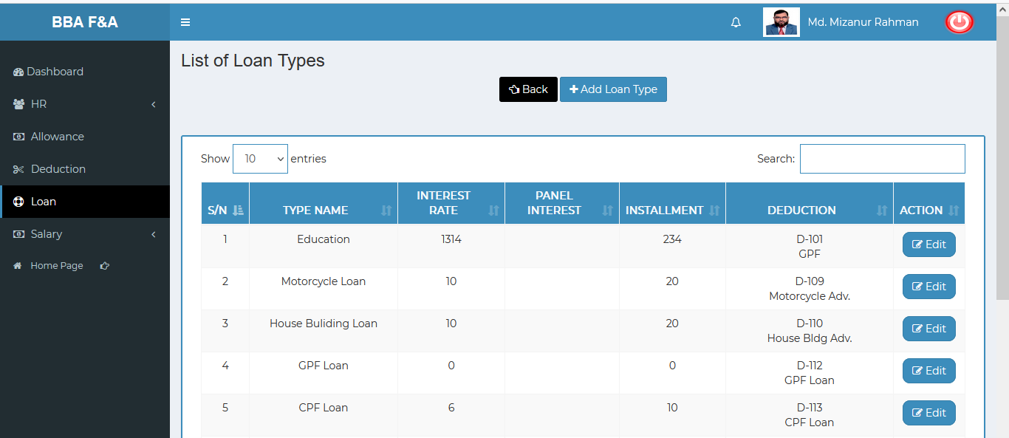

Figure 4.4.1.5: (Loan) view list of loan types

### List of Loan types edit: Click on the edit button after that looks like below scenario will appear. User can update the value as user required.

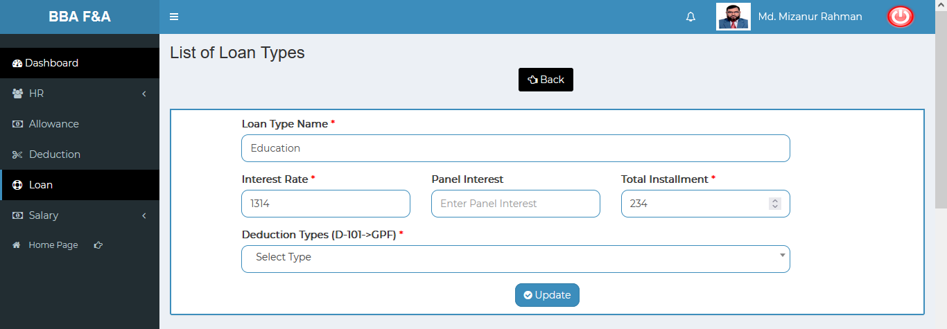

Figure 4.4.1.6: List of loan types edit form

### 4.4.1.7: (Loan) Search loan information

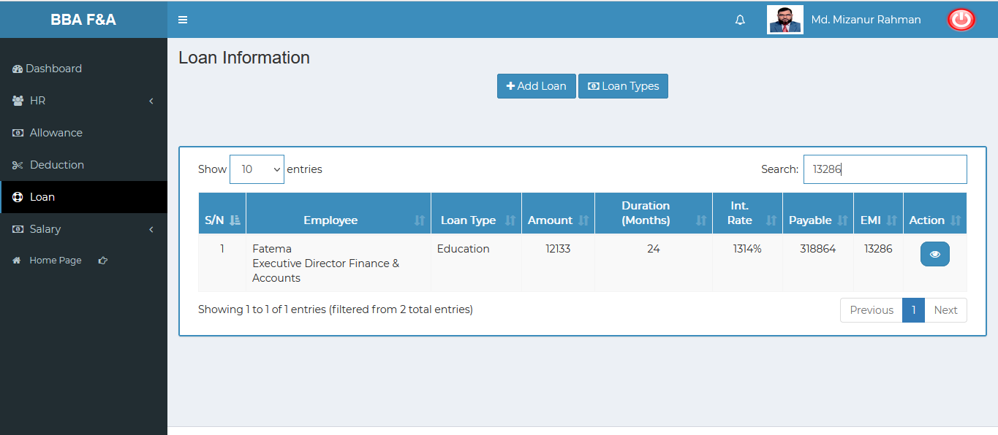

Figure 4.4.1.7: search loan information

## 4.5: Salary Menu Overview

**Overview of Salary**

### 4.5.1.1: Salary Process (Salary) Month wise salary process input field

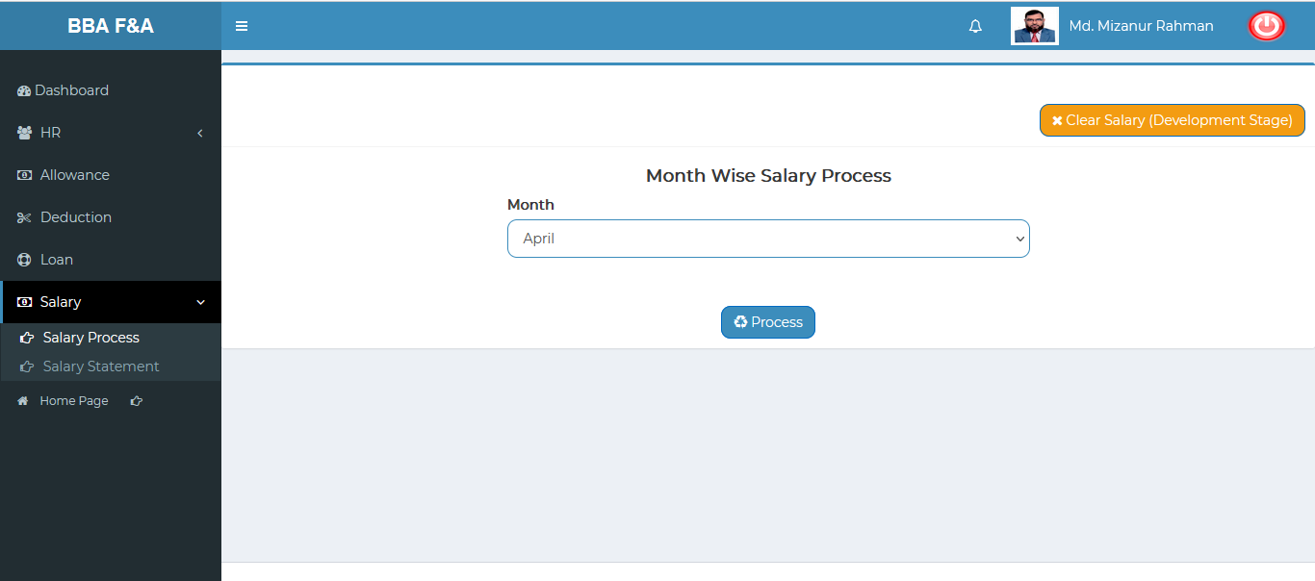

Figure 4.5.1.1:month wise salary process input field

### 4.5.2.1: Salary Statement (Salary) Month and Grade wise salary input field

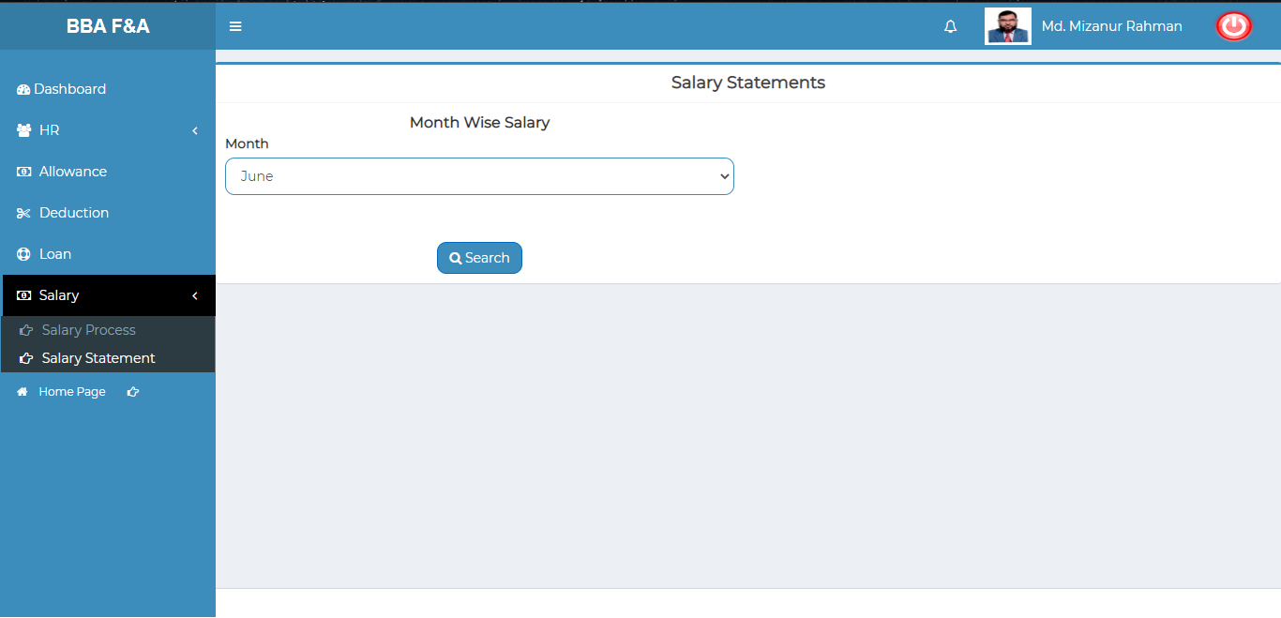

Figure 4.5.2.1: month wise salary input field

Month wise all employee salary report: Fill in the month wise salary input field with appropriate value and clicks the search button ,it will redirect to month wise salary report page

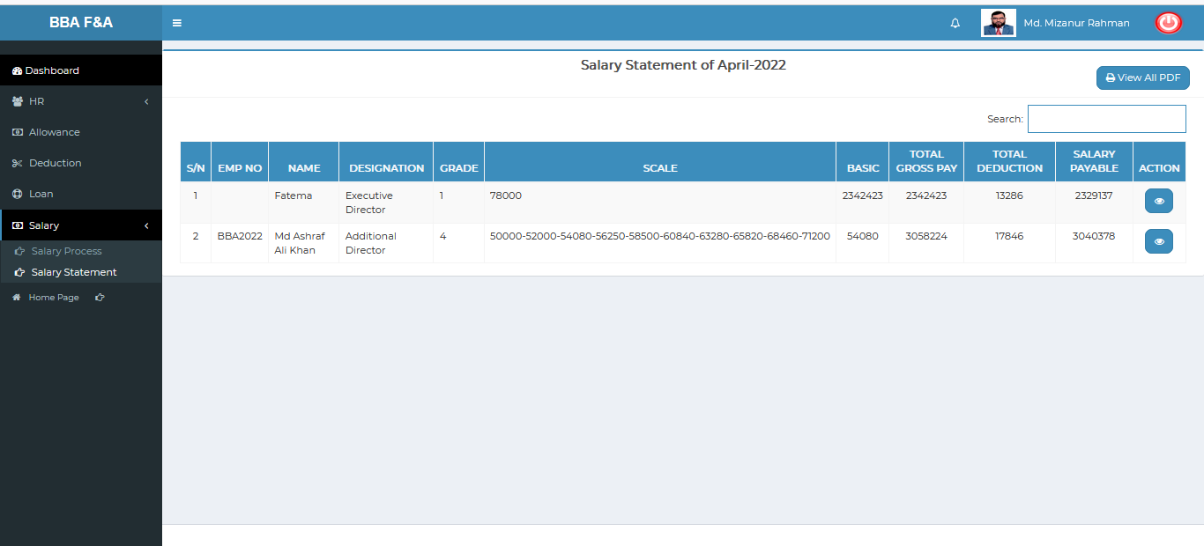

Figure 4.5.2.2: view of month-wise all employee salary report

### Month wise single employee salary Details :

Click on the view button, it will redirect to month wise single employee salary details page.

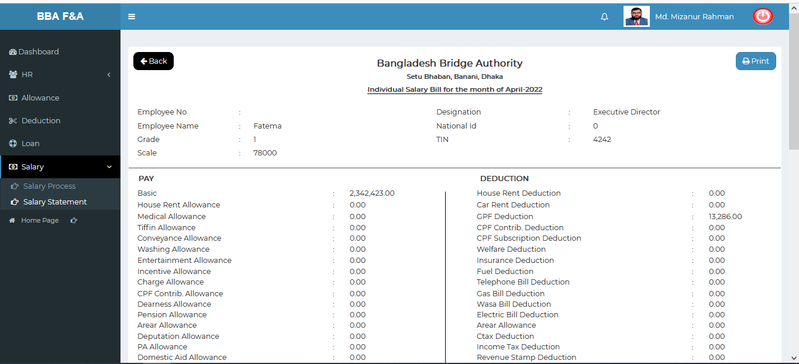 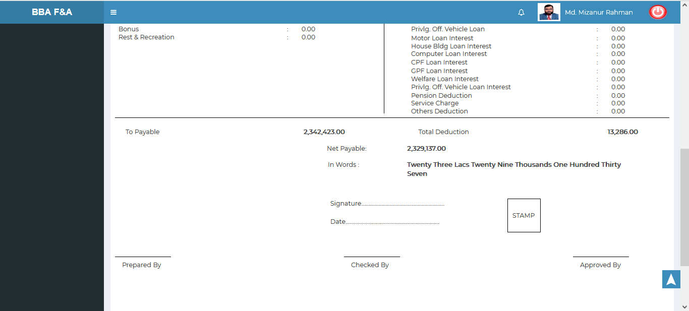

Figure 4.5.2.3: month wise single employee salary details

### Month wise all employee salary report generate:

Clicks the view all pdf button ,it will redirect to month wise all employees salary details page.

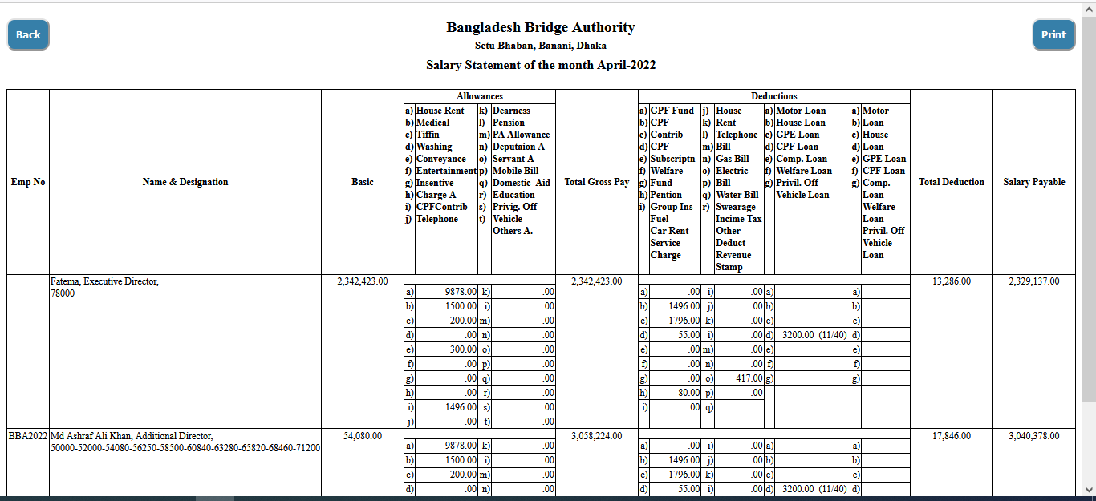

Figure 4.5.2.4: month wise all employee salary report generate

### Month wise all employee salary report Print:

Click on the print button after that looks like printing functionality will appear.

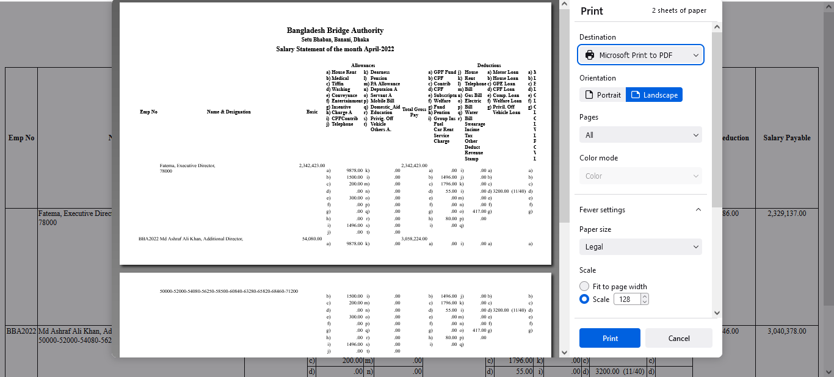

Figure 4.5.2.5: month wise all employee salary report details print

# 5.CPF MANAGEMENT (SUB MODULE)

After clicking into CPF Management, it will redirect to the (CPF Sub Module) dashboard with some menus.

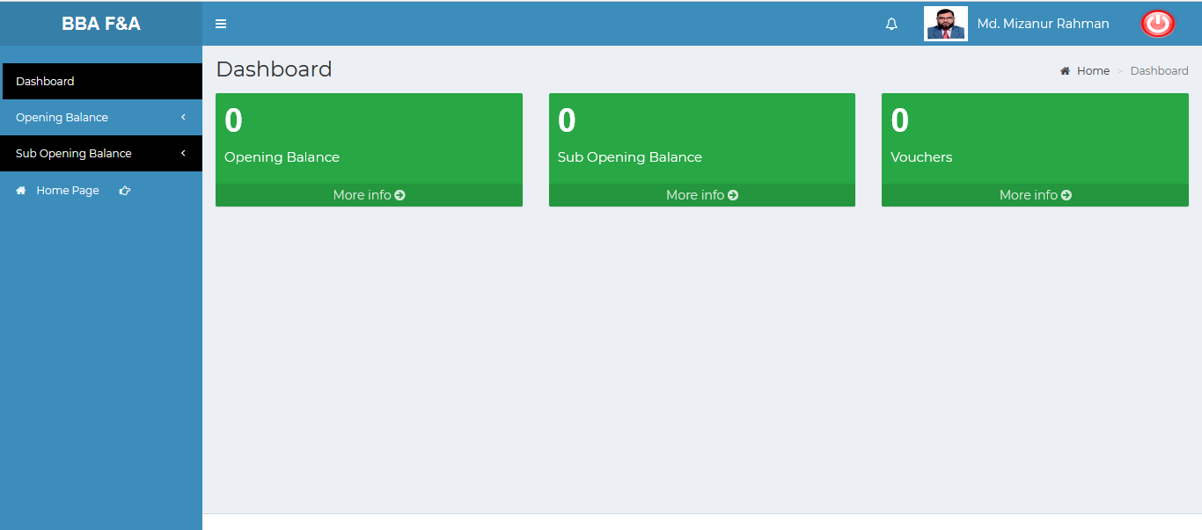

Figure 5: Dashboard of CPF (sub module)

There are three segments on the right side of the CPF Management Dashboard Such as **Opening Balance, Sub Opening Balance ,Vouchers .**

To get the details info about (**Opening Balance, Sub Opening Balance, and Vouchers**) just click on the More info link after that it will redirect to the relevant details info page.

# 6. CPF MANAGEMENT MENUS OVERVIEW

**CPF Management Menu Overview**

## 6.1: Opening Balance Menu Overview

**Overview of Opening Balance**

Click on the Opening Balance menu after that there will appear three (03) sub-menu & they are **Create , Manage** and **Report.**

### 6.1.1.1: Create (Opening Balance) Accounts Opening Balance Entry Form

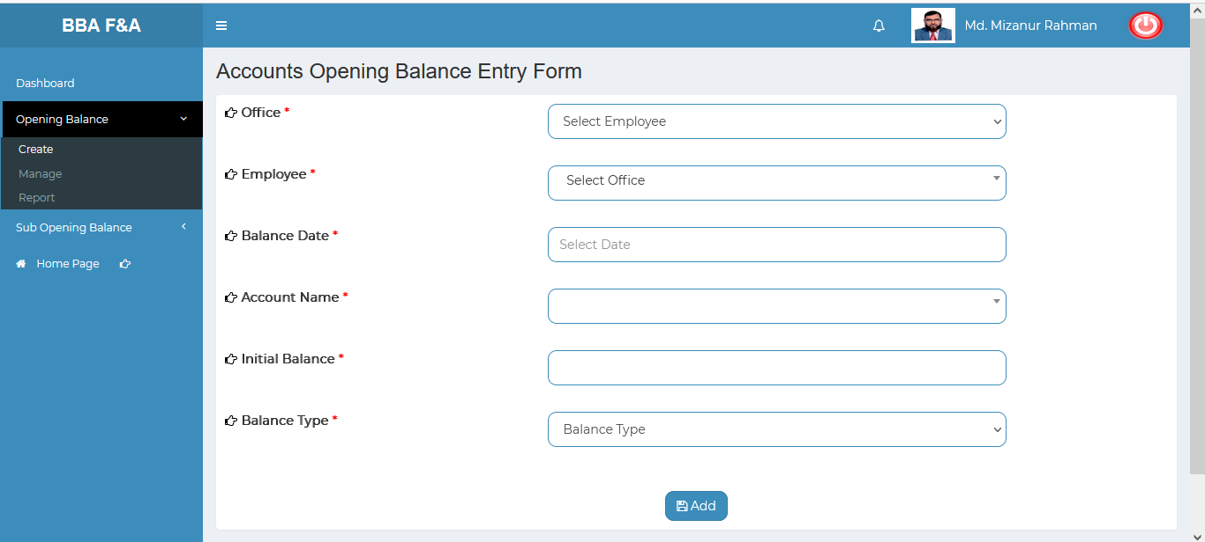

Figure 6.1.1.1: accounts opening balance entry form

### 6.1.2.1: Manage (Opening Balance) View of Details accounts opening balance

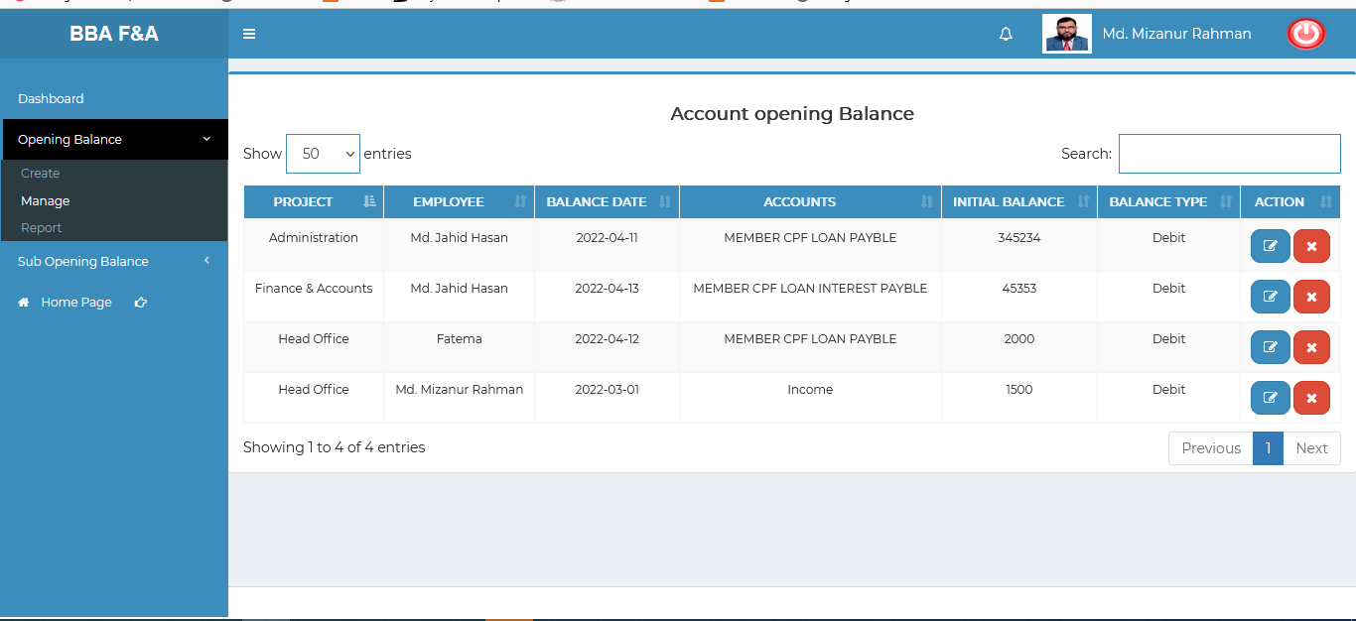

Figure 6.1.2.1: view details of accounts opening balance information

### 6.1.2.2: Manage (Opening Balance) Opening balance data edit form

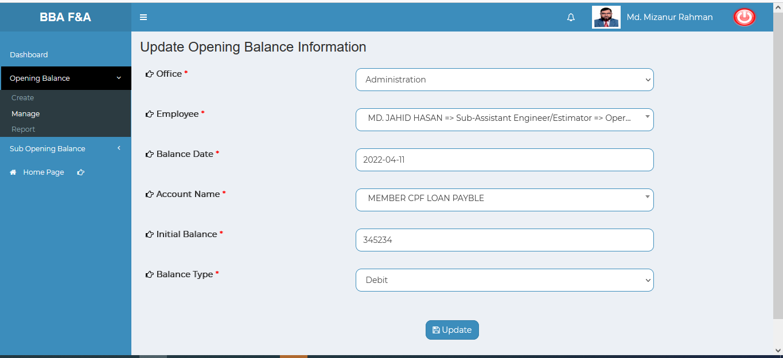

Figure 6.1.2.2: Update opening balance Information

### 6.1.2.3: Manage (Opening Balance) Delete opening balance data

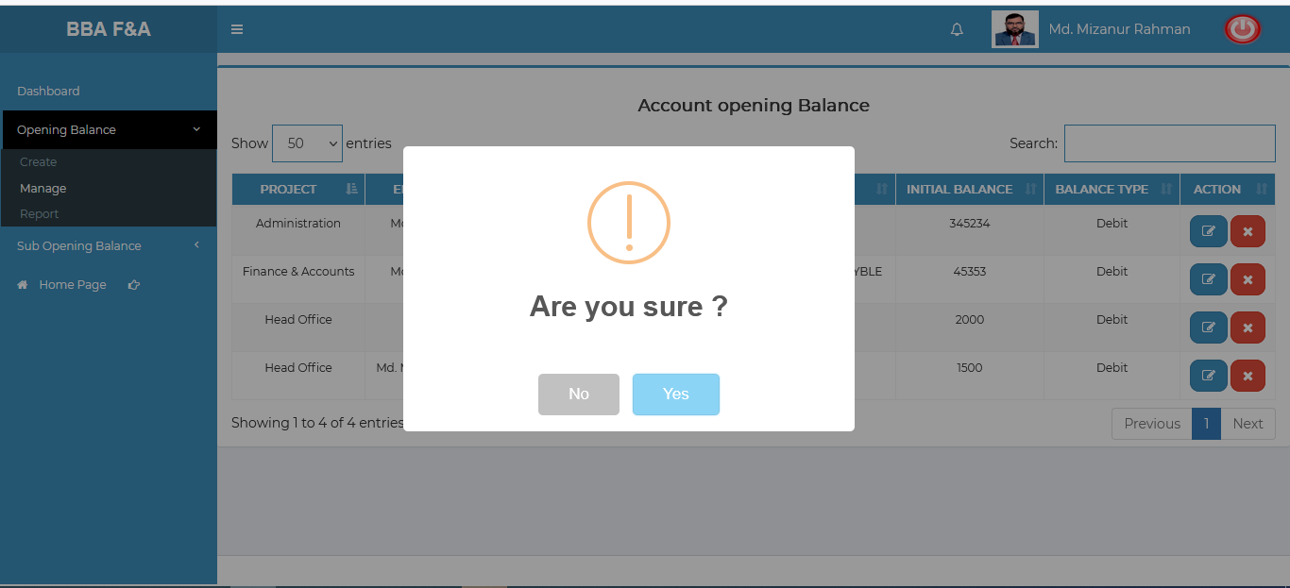

Figure 6.1.2.3: delete opening balance data

### 6.1.2.4: Manage (Opening Balance) Search opening balance data

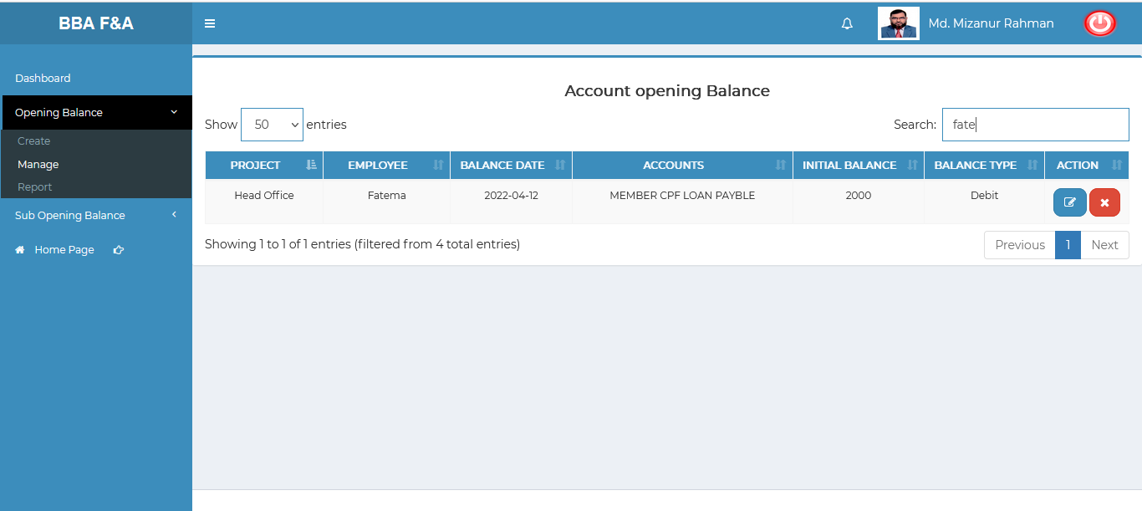

Figure 6.1.2.4: search account opening balance data

### 6.1.3.1: Report (Opening Balance) incomplete(under processing…..)

## 6.2: Sub Opening Balance Menu Overview

**Overview of Sub Opening Balance**

### 6.2.1.1: Create (Sub Opening Balance) Accounts Sub Opening Balance Entry Form

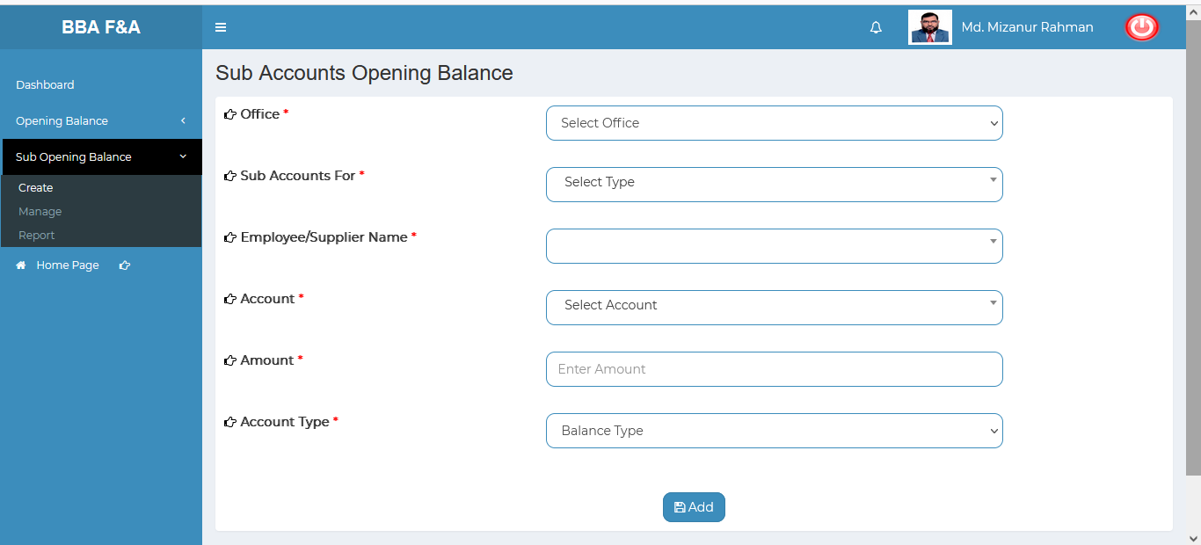

Figure 6.2.1.1: Accounts sub opening balance entry form

### 6.2.2.1: Manage (Sub Opening Balance) View of details sub opening balance

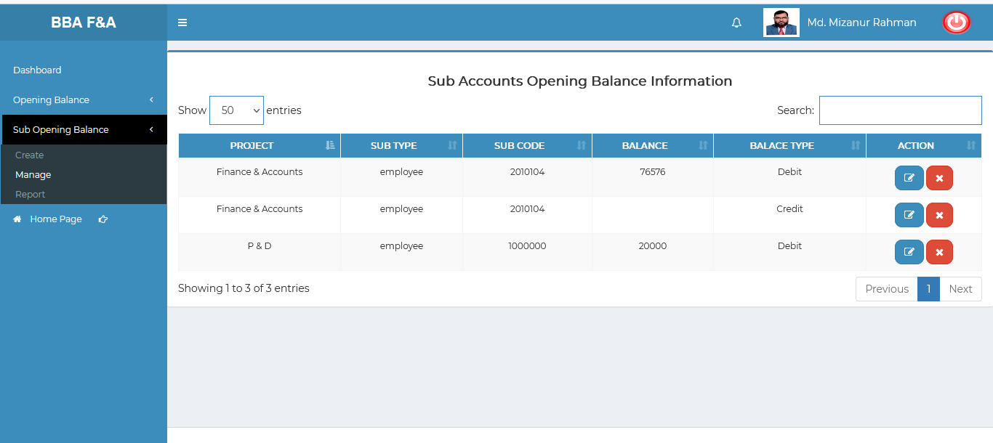

Figure 6.2.2.1: Sub Accounts opening balance information

### 6.2.2.2: Manage (Sub Opening Balance) Update sub opening balance information

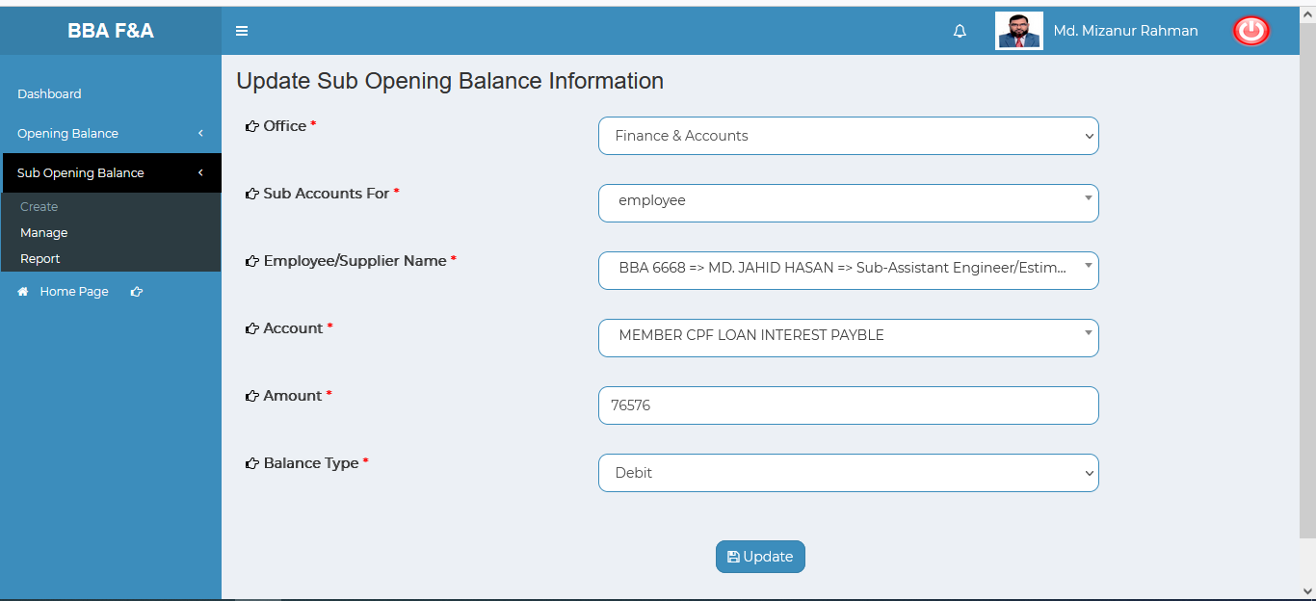

Figure 6.2.2.2: update sub opening balance information

### 6.2.2.3: Manage (Sub Opening Balance) Sub opening balance data delete

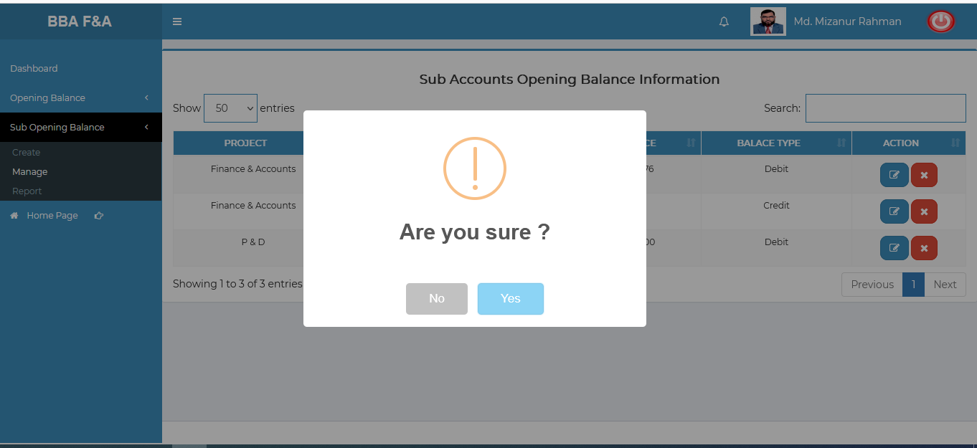

Figure 6.2.2.3: Sub Opening balance data delete

### 6.2.2.4: Manage (Sub Opening Balance) Search Sub Accounts opening balance information

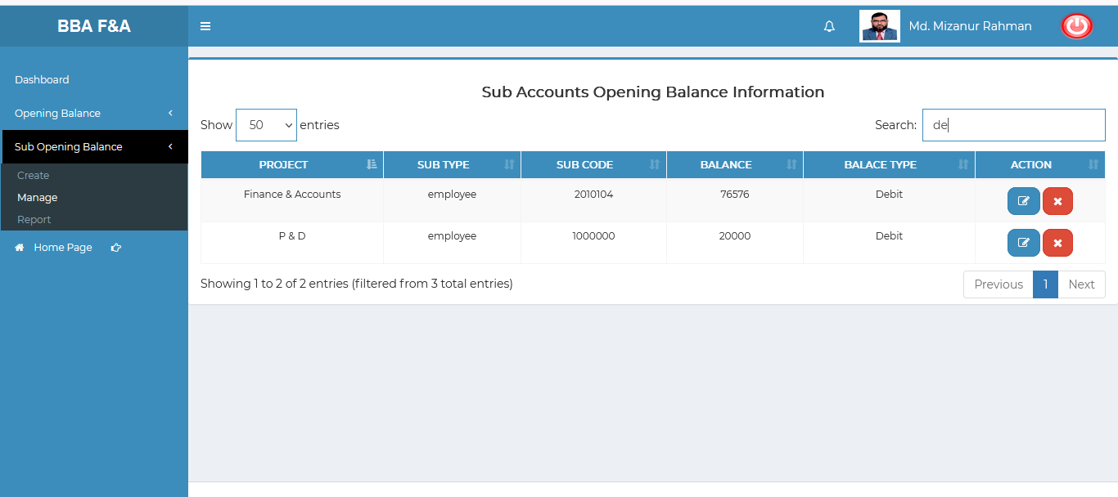

Figure 6.2.2.4: search sub accounts opening balance information data

### 6.2.3.1: Report (Sub Opening Balance) incomplete(under processing…..)

# 7.FDR MANAGEMENT (SUB MODULE)

After clicking into FDR Management, it will redirect to the (FDR Sub Module) dashboard with some menus.

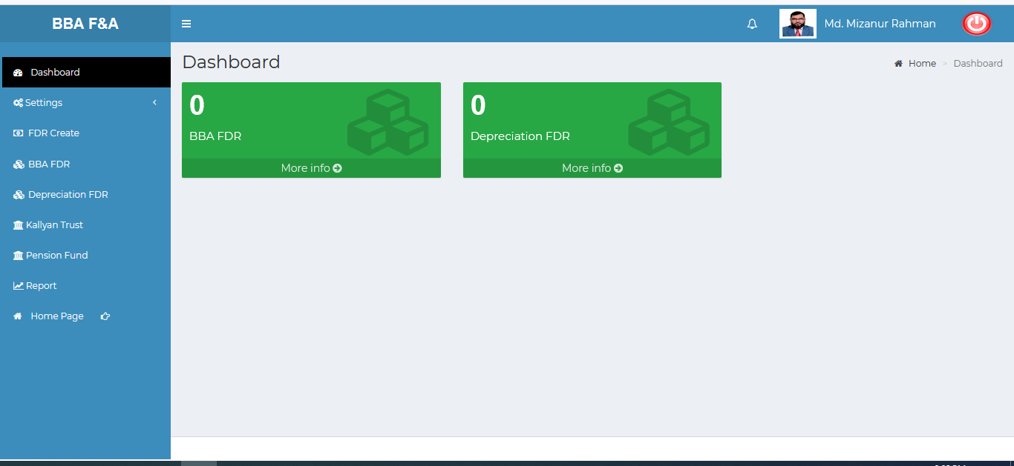

Figure 7: Dashboard of FDR (sub module).

There are two segments on the right side of the FDR Management Dashboard Such as **BBA FDR** & **Depreciation FDR.**

To get the details info about (**BBA FDR , and Depreciation FDR**) just click on the More info link after that it will redirect to the relevant details info page.

# 8.FDR MANAGEMENT MENU OVERVIEW

**FDR Management Menu Overview**

## 8.1: Settings Menu Overview

**Overview of Settings**

### 8.1.1.1: Bank (Settings) Add Bank Entry Form

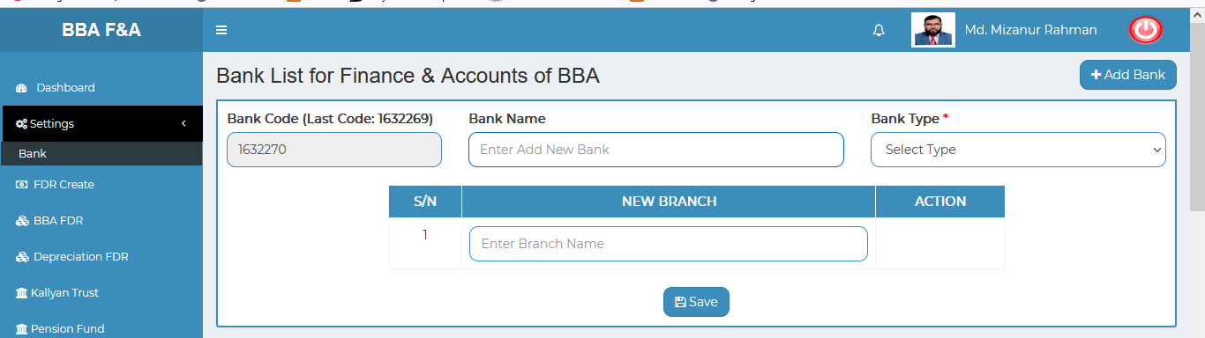

Figure 8.1.1.1: bank (Settings) add bank entry form

### 8.1.1.2: Bank (Settings) View details of bank

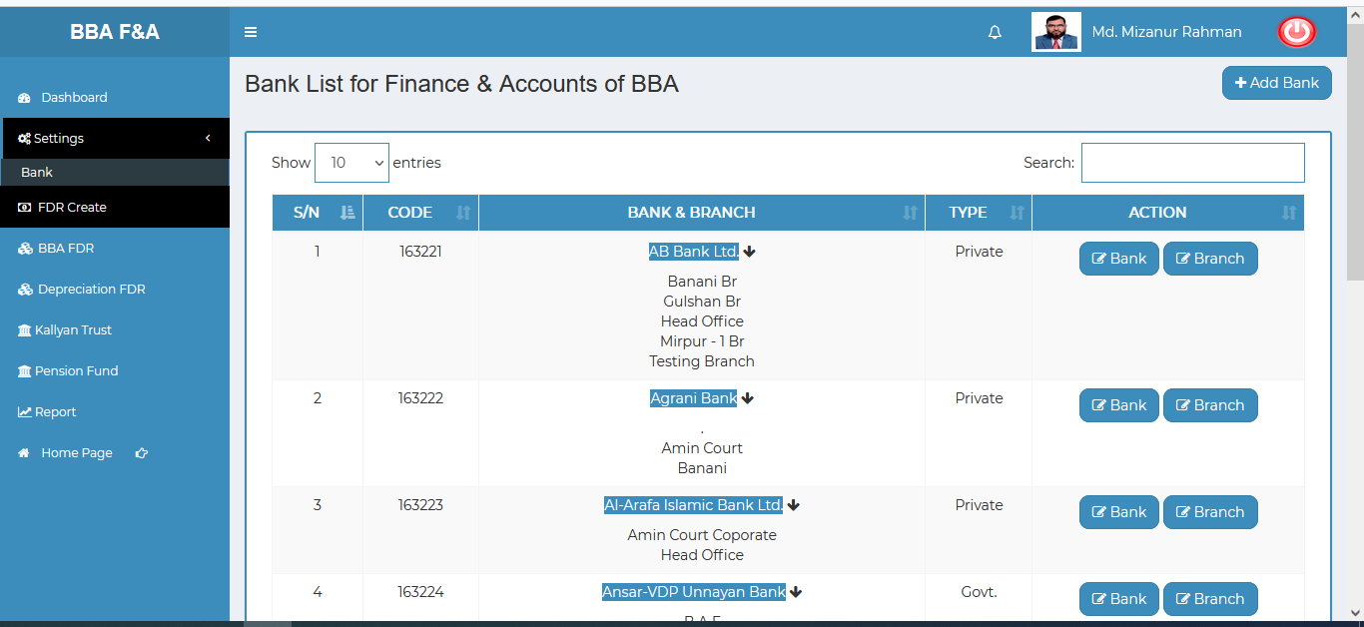

Figure 8.1.1.2: bank(settings) view details of the bank

### 8.1.1.3: Bank (Settings) Update bank type info

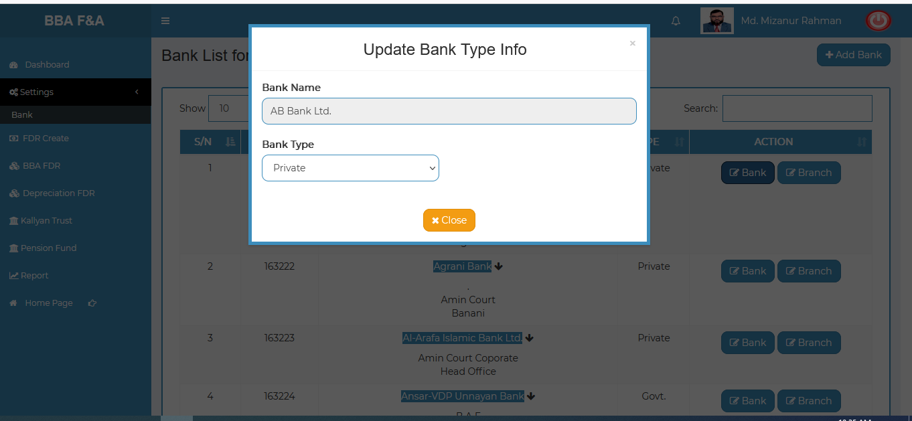

Figure 8.1.1.3: bank(settings) Update bank type info

### 8.1.1.4: Bank (Settings) Update branch type info

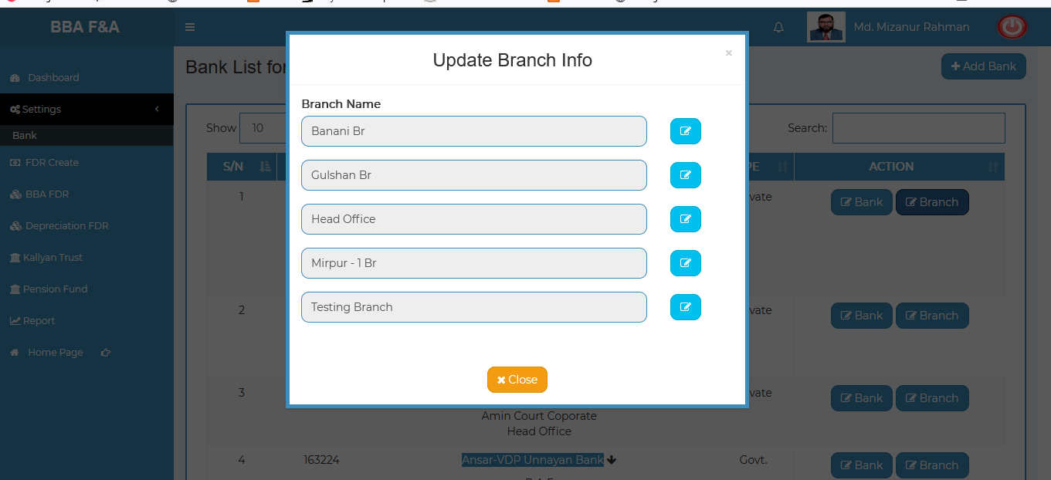

Figure 8.1.1.4: bank(settings) Update branch type info

### 8.1.1.5: Bank (Settings) Search

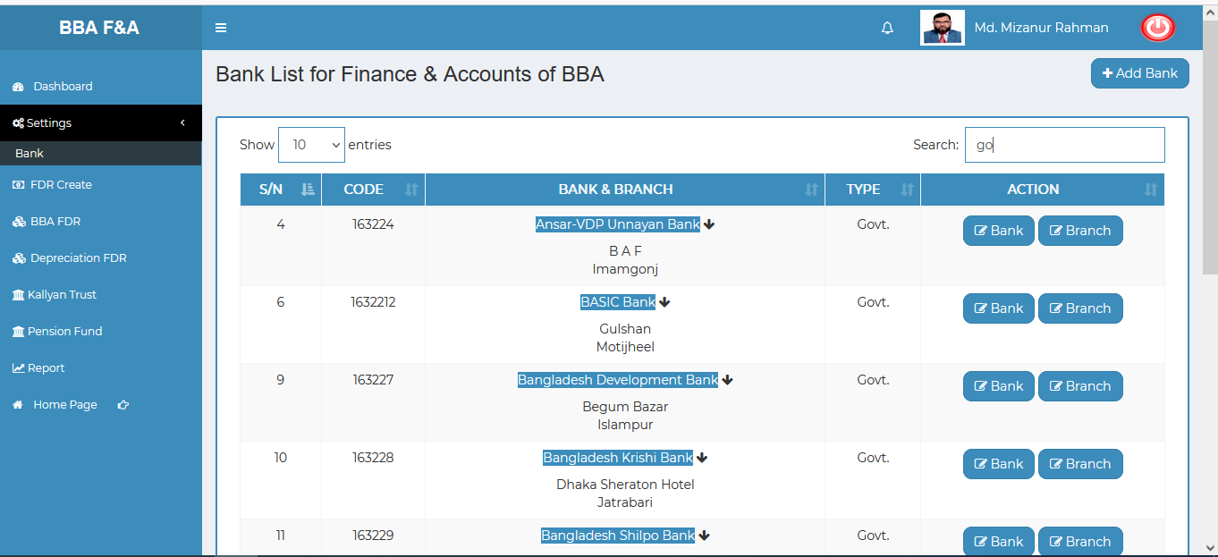

Figure 8.1.1.5: bank(settings) search

## 8.2: FDR Create Menu Overview

**Overview of FDR Create**

### 8.2.1.1: (FDR Create) input field

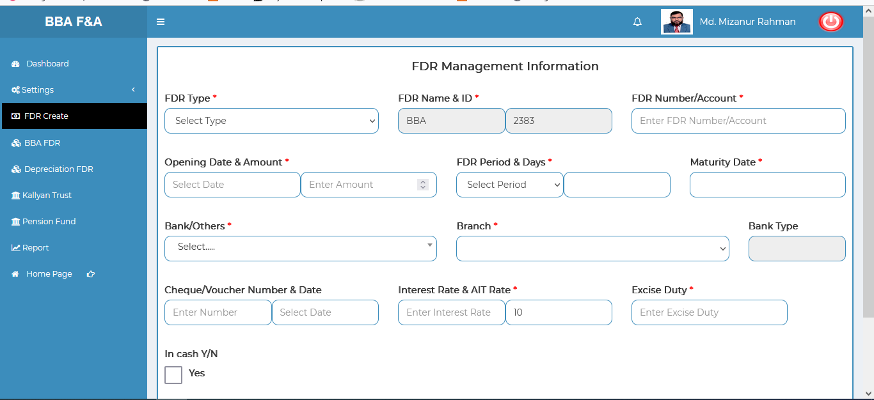

Figure 8.2.1.1: (fdr create) input field

## 8.3: BBA FDR Menu Overview

**Overview of BBA FDR**

### 8.3.1.1: (BBA FDR) View of BBA FDR Information

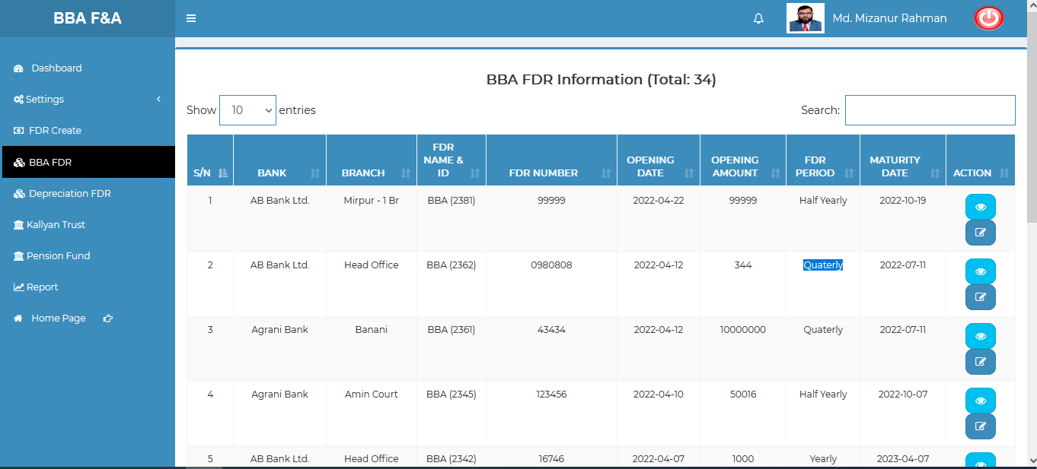

Figure 8.3.1.1:(BBA fdr) view of BBA fdr information

### 8.3.1.2: (BBA FDR) View of Single Details

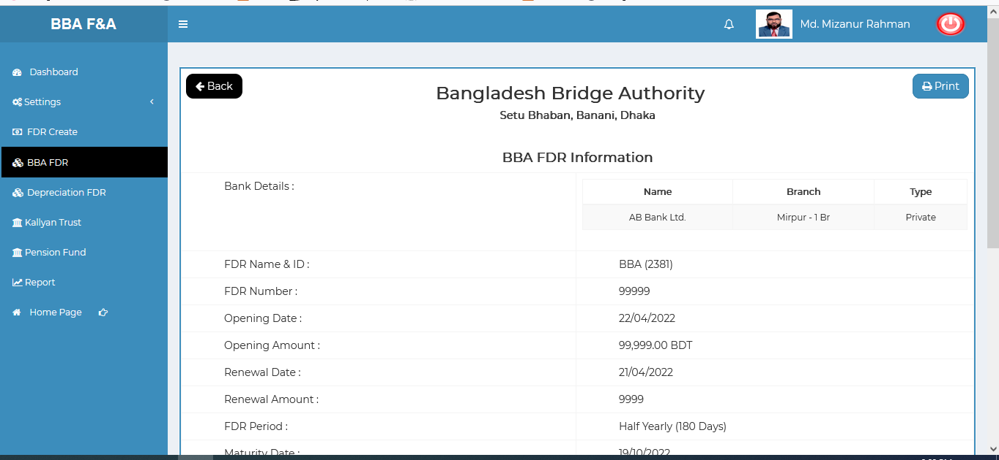

Figure 8.3.1.2: (BBA FDR) view of single details

### 8.3.1.3: (BBA FDR) Update input form

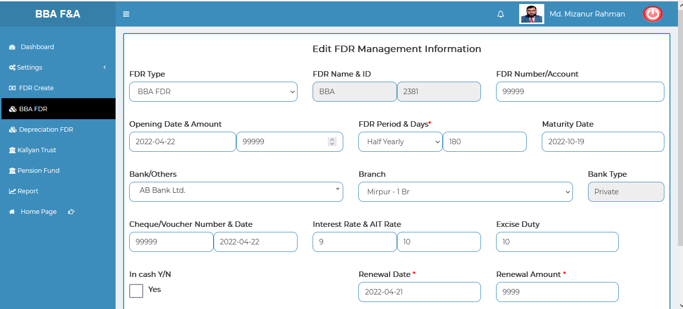

Figure 8.3.1.3: (BBA FDR) update input form

### 8.3.1.4: (BBA FDR) Search

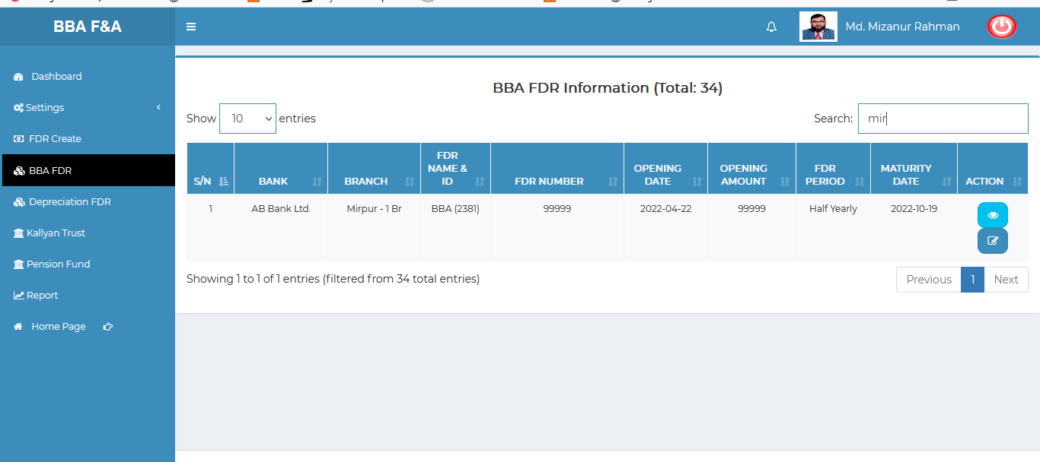

Figure 8.3.1.4: (BBa FDR) search

## 8.4: Depreciation FDR Menu Overview

**Overview of Depreciation FDR**

### 8.4.1.1: (Depreciation FDR) View of Depreciation FDR Information

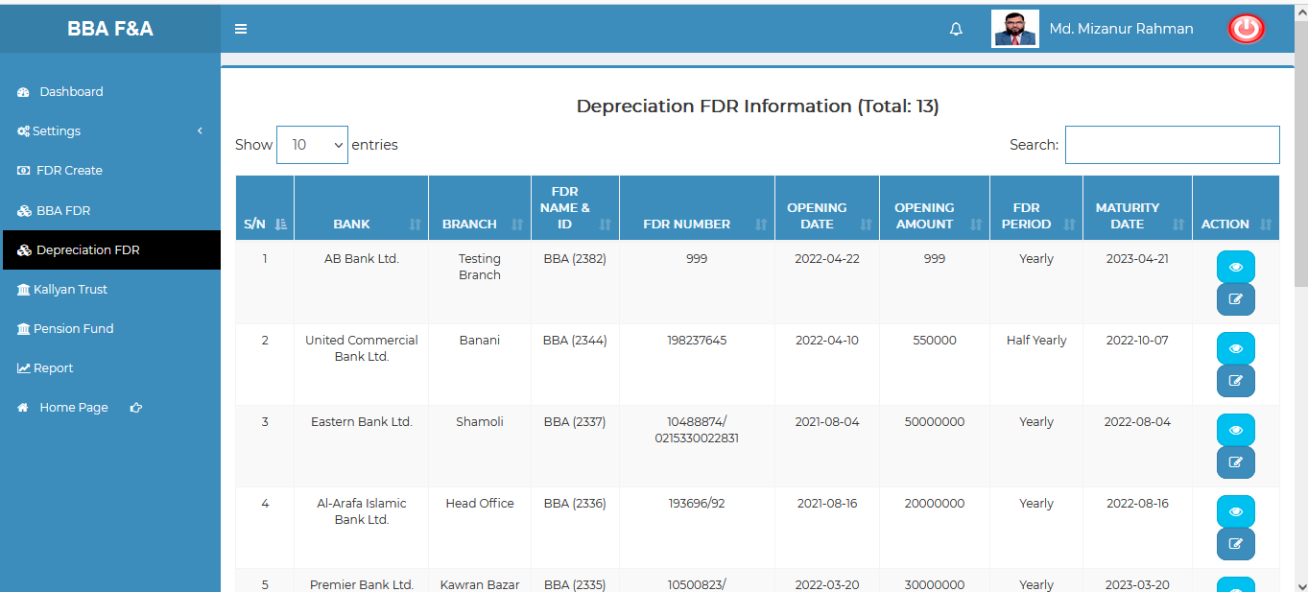

Figure 8.4.1.1: (depreciation FDR) view of depreciation fdr information

### 8.4.1.2: (Depreciation FDR) View of Single Details

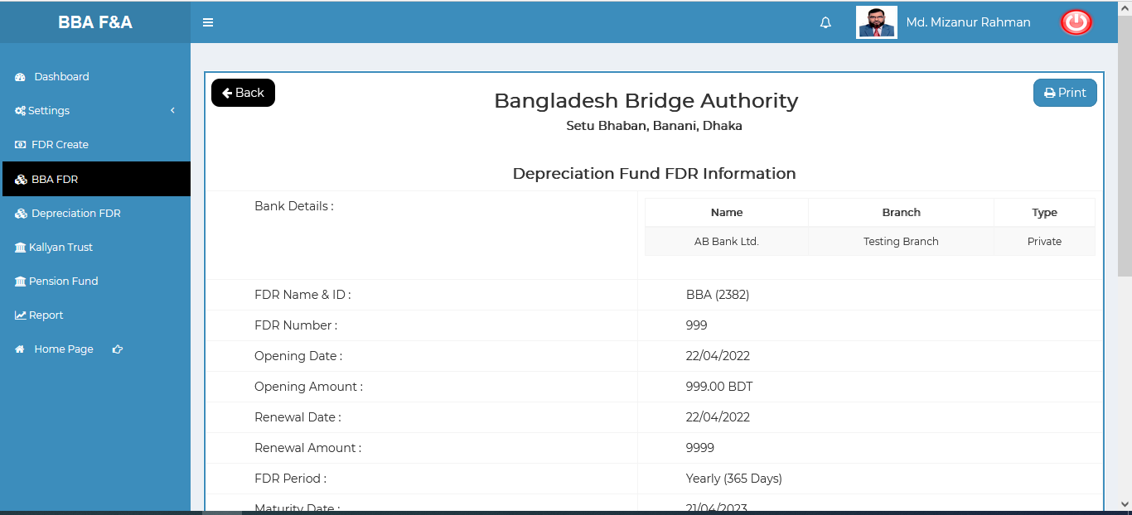

Figure 8.4.1.2: (depreciation FDR) view of depreciation single details

### 8.4.1.3: (Depreciation FDR) Update input form

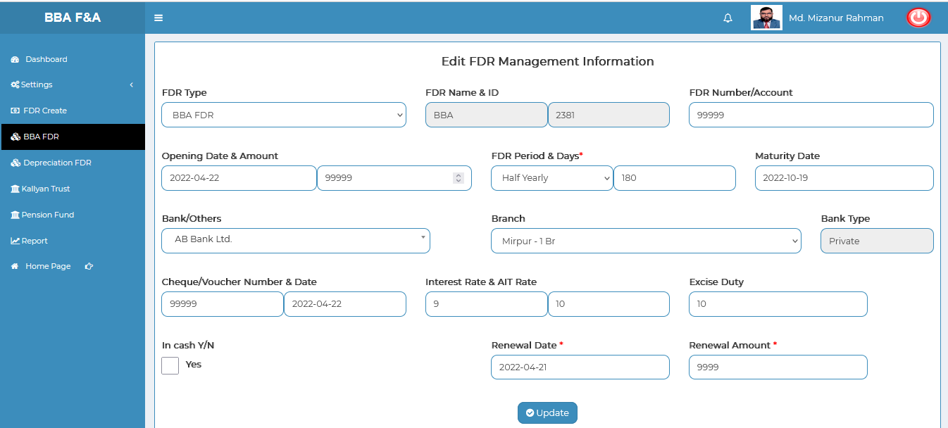

Figure 8.4.1.3: (depreciation FDR) update input form

### 8.4.1.4: (Depreciation FDR) Search

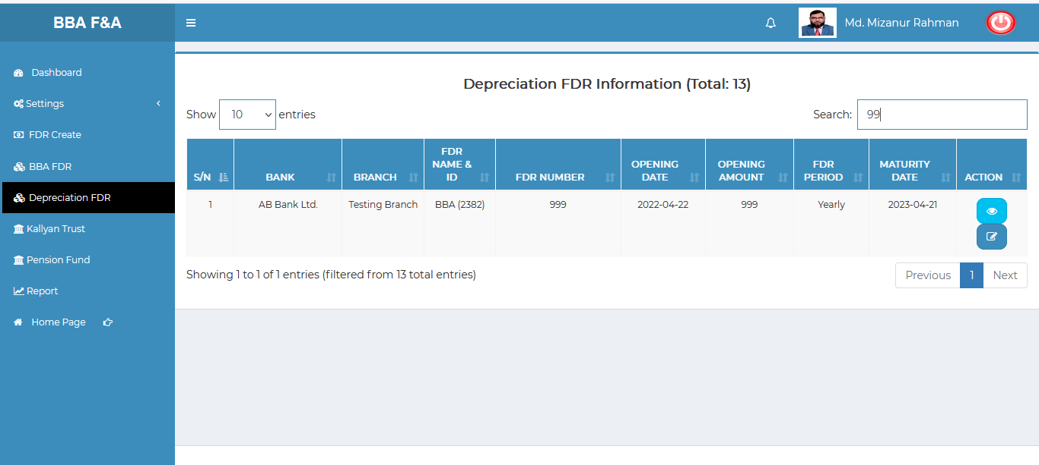

Figure 8.4.1.4: (depreciation FDR) search

## 8.5: Kallyan Trust Menu Overview (Not working ,under processing……)

## 8.6: Pension Fund Menu Overview (Not working ,under processing……)

## 8.7: Report Menu Overview

**Overview of Report**

### 8.7.1.1: (Report) FDR Report generator input field

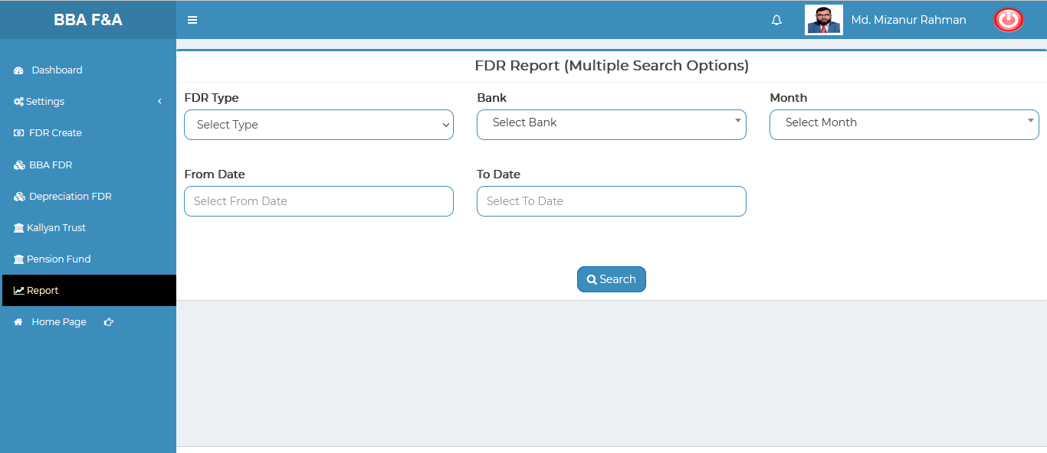

Figure 8.7.1.1: (Report) fdr report generator input field